CITY VET HUB: A Municipal Ecosystem for Spatial Surveillance, Smart Traceability, and Personalized Pet Adoption



An Undergraduate Thesis Project Presented to the Faculty
of the College of Computer Studies
St. Michael’s College
Iligan City

By

ABDULGANI, ABDUL MOHSEIN S.
LUCASAN, KRISHAN NIKO M.

JUNE 2026

Chapter 1

THE PROBLEM AND ITS SETTING

Introduction
Keeping cities safe and sustainable means dealing with animals in smart ways. Cities are developing fast and animals are having fewer places in the wild and will be interacting with humans more. In Iligan City, that job falls to the City Veterinary Office tracking who owns which animals, monitoring disease outbreaks, especially rabies, then collecting strays off streets while trying to find them new homes. But now there are too many unlisted pets, neighborhoods spreading quick, making it harder each year just to keep track. What once worked starts falling short.
Currently, many local animal health departments stick to scattered methods or handwritten logs. Small and medium-sized veterinary clinics are finding it difficult to efficiently run their operations and provide quality services to their clients due to the increasing demand for pet care, especially considering their acute shortage of veterinary staff (Bucao et al., 2023). Without a centralized system, reacting quickly to disease outbreaks becomes tough. Along with finding strays, a shelter to call home. If records stay on papers responding to this task and receiving up to date data will prove challenging.
Fixing deep rooted issues requires updating public health systems for pets using smart software tools. Research shows that web-based platforms widen access and streamline shelter adoptions by cutting out slow paperwork steps (Alsuwailem et al., 2022). Instead of guessing, officials receive live updates from automatic location tracking. This helps them identify outbreaks faster and take action sooner (Hofstra et al., 2022). With a connected digital system that combines mapping features, the city moves from reacting to problems after they escalate to staying ahead with clear signals and timely actions.
In Iligan City, improving processes provides officials with live updates and location maps by linking data to each animal. Studies find that digital IDs work much better than traditional ear tags for tracking or returning lost pets (Klune et al., 2021). This main system replaces tedious tasks previously done by hand, while also encouraging community involvement. Over time, using technology like this transforms care for stray and owned animals into a quick, transparent process focused on safety for everyone.

Statement of the Problem
The current city veterinary offices do not have a centralized digital system, leading to many bottlenecks in their operations. These bottlenecks slows down the CVOs ability to provide public service :
- Most of the time, tracking diseases across areas happens too late. A village might report rabies, yet officials still work without live maps showing where cases cluster. Without a digital map, finding the affected areas becomes confusing. That delay means help often arrives after the outbreak has already jumped. With the slower response times vaccines will be arriving late and the disease might have already spread.
- Most pet tracking systems operate separately, so checking vaccines or returning strays gets confusing. When animals are picked up, staff often can’t find their owners, having no shared database slows everything down.
- The process of taking home a pet from the city shelter demands trips in person instead of an online system that works. Crowded shelters pile up because getting animals data is too slow.
- Writing things down by hand really drags the process out. The absence of a central system for computers makes collecting all those animal data points results in lots of paperwork that accumulates. That way of doing things makes resource allocation difficult based on data.

Objective of the Study
The researchers aim to build a centralized web and mobile system that help Iligan city in managing the animal diseases and stray population. A centralized system that will help the CVO in their work and a mobile application for the citizens of Iligan city.
- To design a spatial disease surveillance system for mapping reported animal diseases and tracking vaccination coverage across Iligan City by implementing Kernel Density Estimation (KDE) for hotspot heatmap generation and DBSCAN clustering for automated outbreak detection.
- To develop a smart traceability mechanism that uses a secure digital ID using QR codes. Allowing veterinarians to receive a pet's medical and ownership history via mobile scanning.
- To streamline the adoption workflows by implementing a direct-posting adoption system and community hub, allowing citizens to list pets for peer-to-peer adoption and engage in discussions, alongside CVO administrators and field officers who can upload rescued or surrendered animals, utilizing a content-based filtering system designed to personalize pet discovery and recommendations for potential adopters.
- To implement a centralized database and API gateway capable of securely sharing appropriate data according to the user and ensuring the backend can process complex spatial data and handle high-volume querying without issues.

Scope and Limitation of the study
This study aims to develop a complete web and mobile platform built specifically for the Iligan City Veterinary Office. It connects an administrative dashboard used by veterinarians with mobile access for external entities, including veterinary clinics, animal shelters, barangay officials, and citizen users. The web administration panel is built using standard HTML, CSS, and JavaScript, while the mobile application utilizes the React Native Expo framework for cross-platform accessibility. The backend infrastructure, database management, and API services are hosted and managed through Appwrite.io. This platform enables a direct-posting adoption system supporting both peer-to-peer citizen adoptions and official CVO uploads, alongside a community hub for public posting and commenting. Maps powered by external geospatial services display disease reports employing Kernel Density Estimation to generate visual heatmaps and Density-Based Spatial Clustering of Applications with Noise (DBSCAN) for outbreak detection. Crucially, to adhere to CVO protocols and prevent public panic, heatmaps and outbreak alerts are strictly restricted to field officers and administrators, while citizens are limited to only submitting disease incident reports. A separate module issues digital identification documents using scannable QR labels assigned when pets are logged into the system.

Although focused on digital monitoring and record keeping for the Iligan City Veterinary Office, this study does not cover clinical diagnoses. Tracking systems involve changing geographic patterns of documented diseases, immunization rates, together with concentrations of unowned animals. However, the scope of this system is strictly limited to cats and dogs. Furthermore, the disease tracking and outbreak detection features are specifically focused on common pet diseases, which include rabies, canine parvovirus, and ringworm. Lab-based disease studies or monitoring illness changes play no central role here.

Starting with mock data, information for trial runs follows routines like those at the Iligan City Veterinary Office. When live, the platform depends on steady web access so updates appear instantly on dashboards. Wildlife outside human care, any animals other than cats and dogs, and the internal processes of other city offices are completely outside the scope of this study.

Significance of the Study
The following individual will benefit from this study:

Municipal Veterinary Offices and Local Government Units. The Iligan City Veterinary Office (CVO), will have access to a centralized web and mobile system that will make deployment of resources, such as deploying anti-rabies vaccination programs to specific areas where heat maps show a low coverage of vaccinations easier. In addition, a safe and secure QR-based registry will lessen the burden of paperwork for the CVO personnel.
Citizens of Iligan City and Pet Owners. The citizens will gain access to a mobile based solution for making pet registrations easier. The citizens will be notified of disease outbreaks via their mobile devices. Using this platform, pet adoption becomes much easier, stray pets can be reported and kept safe, and their health records can be managed.
Computer Studies Practitioners. Software developers and Computer Studies Practitioners may use this study's findings specifically the integration of geospatial mapping and state machine logic within a centralized web and mobile system as a reference for digitizing and streamlining other local government workflows and public service systems.
Researchers. This study aims to make a well defined system and baseline for future research into municipal governance, spatial disease surveillance, and smart traceability. The system architecture, database design, and workflow automation logic gives a respectable foundation for studies in urban animal management.
Future Researchers. Future researchers may use the findings of this study for future references. This study can be used as a different viewpoint on systems that track pets digitally via web and mobile systems. The findings from this study can show some guidance for future research within the domain of data driven veterinary science.

Definition of Terms
API Gateway. A centralized software intermediary serving as a connection between the mobile application used by the citizens and the CVO Web Panel to have a smooth synchronization.
Smart Traceability. A system incorporating the usage of digital IDs in the form of a QR code that is generated once registration is done to be able to access the complete history of the pet instantly.
Spatial Disease Surveillance. A Module that will be used in geospatial analytics to generate heat maps in real time for disease outbreaks, vaccination, and stray animal groups.
Web Administration Panel. A system that will be used only by the CVO members who access spatial data regarding the animal adoption process, disease tracking and member managements.
State Machine Logic. This is the process that will be used in tracking the process of the animal from the point of being rescued through adoption.
Zoonotic Diseases. Animal diseases that can be transmitted from one living being to another.

CHAPTER 2

REVIEW OF RELATED LITERATURES
Through this chapter the researcher will present a review of existing literature and studies relevant to the topic of the study.

Review of Related Literature
Efficient management of animals in urban areas needs a thorough knowledge of contagious animal diseases that pose risks to the health of the animals as well as the citizens. According to various articles on veterinary health, there are two diseases which are in need of high concern including Canine Parvovirus (CPV) and Rabies. Rabies is a serious public health concern in the Philippines, it is mainly caused by the bites of stray animals who are not vaccinated. The Parvovirus is a very contagious and environmentally robust disease that results in fatal gastroenteritis among unvaccinated puppies . Various blogs dedicated to the animal disease cases highlight the importance of implementing a proactive approach in managing these diseases in order to reduce their spread from one place to another.(American Veterinary Medical Association, 2023)
Today’s software utilizes external resources, particularly mapping interfaces, to analyze geographic pattern trends. Rather than building the entire system from scratch, developers rely on platforms such as Google Maps or Mapbox. With these connections established, icons for cases of rabies or stray animals will be displayed directly on the map of the city. Clarity will be achieved through grouping, facilitated by an inherent group of algorithms and color scales related to the density of the clusters. The numbers become much more meaningful when placed against a map of the city and its recognizable districts. Identifying problem areas will be much easier since visual information is easier to interpret than numerical one. Advanced GIS techniques will become redundant in such conditions. (Boyle, 2022)
Animal adoption is fun, and you can adopt any animal, no matter how big or small. The Adoption Program enables individuals, corporate houses, schools, families, and groups to participate and make a valuable contribution towards the care and enrichment of all the animals living at the Warangal Zoo. So, the adoption fees not only help us to take care of the animals, the money also goes towards the protection of endangered species. Your contribution provides the necessary help to advance the zoo’s work with wildlife conservation organizations worldwide. It is also a rare opportunity to teach children and adults to take care of living creatures and to understand the environment that wild animals belong to. You can help make a difference. Adopting an Animal is a great gift for friend and family celebrations and special occasions. The adoption program is a novel way to show your support and care for wild animals. By adopting your favourite animal, you will contribute towards feeding the animal for one full year. Annual animal adoption is a fun and rewarding way to support zoo vital breeding and conservation programs while creating a lifetime connection with your favourite species. Your adoption money will help us to take good care of the animals, protect endangered species, and work hard with our conservation efforts around the world. Adoption makes a great gift for birthdays, anniversaries etc. and is always unique.(Krishna et al., 2025).
The use of spatial models together with machine learning is changing how infectious diseases are monitored across the United States, making it easier to detect threats earlier, sort risks more accurately, and improve live updates on
outbreak conditions. However, the conventional techniques used in surveillance have their limitations such as late reports, dispersed information, and diverse geographic coverage, making it difficult for them to detect the transmission characteristics of diseases. In contrast, the merger of machine learning techniques and GIS presents a new possibility where different factors related to epidemiology, environment, behavior, and mobility can be combined to forecast at-risk locations. The systematic narrative review encompasses scientific research concerning recent advances in machine learning surveillance. The aspects considered include the differences in methodology, application within urban and remote areas, as well as implications of applying machine learning techniques in disease surveillance. It was revealed that cities are characterized by high-quality digital infrastructure and data flow, making the process more precise, whereas remote territories suffer from the lack of proper documentation, information infrastructure, or equal access to information resources, which impedes the application of machine learning approaches. Some conflicting issues, such as discrepancies among various local trends, different sources, or inconsistent findings, call for a unified methodological framework in the analysis of diseases, as well as transparency of the entire procedure. In the future, design strategies for protecting patient confidentiality, using machine learning approaches to monitor remote locations, as well as adopting the One Health strategy to address animal-caused or weather-related infections are expected to emerge. (Balinang et al., 2026).
Cloud systems have been playing an important role in the management of animal sheltering because there is a mobile application that helps track animal intake, medical reports of the animal, and worries regarding animal management. Animal control organizations, as well as animal shelters, use cloud applications for their operations that take advantage of the use of mobile application technology, thus making it possible for organizations to engage in activities such as animal adoptions and other activities related to cloud computing technology. This not only cuts down IT costs but makes the management of data easy for organization(Hemavathy, K., & Varshini, B., 2024)
By integrating these veterinary and technological concepts, we will create the City Vet Hub ecosystem, which will be an extensive platform designed for Iligan City. Using Appwrite.io as a Backend-as-a-Service (BaaS), the system will be able to support a single, centralized database that will keep track of all the pet registry and adoptions information seamlessly across both the HTML/CSS/JavaScript web panel and the React Native mobile application. Moreover, by utilizing the mapping API in our application, it will be possible for the Spatial Disease Surveillance function of the system to provide heatmap maps of rabies and other diseases like parvovirus in the different barangays in the city. Lastly, the system will have a Smart Traceability feature that will allow us to produce QR codes for each registered pet, and by scanning through these codes using the mobile app, it will be possible for us to access their health record.

Review of Related Studies
This paper concerns pet adoption by building a web-based platform that supports the idea of using technology for the pet adoption process in Saudi Arabia, the eastern province in specific. The difficulty of the adoption process and putting pets up for adoption is a real problem in our society. In this regard, we put forward the idea of "Leen" to provide easy and quick services for this process and make it accessible to all interested people. Our platform offers many services such as adoption, pet care, donation, Etc. However, the main point in the "Leen" platform is that all services provided are free with no fees. A "Leen" platform user can offer a pet for adoption to find a home with another user from "Leen". Also, a user can look for pet care clinics at their nearest location in the region. Furthermore, a user can directly donate to trusted adoption associations in Saudi Arabia. "Leen" platform was built to provide the mentioned services and more. Eventually, having the platform within reach of users will provide all the services faster and easier than usual. (Alsuwailem, R., Almobarak, R., Aboali, R., Alrubaiea, S., & Aldossary, J., 2022)
The research centered on the utilization of a mobile app with location-based capabilities created in the React Native Framework for the purpose of pet adoption. The core inquiry revolved around assessing the efficacy of the CareForPaws mobile app’s functionalities, which encompass pet adoption management, monitoring systems, and personality & location-based matching. The procedure of obtaining information during the research involved the use of a selective sampling technique. The use of selective sampling involved choosing particular people who would participate in the research mostly from the Facebook population. This was preferred by the researchers since it enabled them to exercise discretion when choosing suitable participants. The selected participants had access to the application where they could test and assess the application. Thereafter, some adjustments were made to the app through the input obtained from the testers. According to the results of the study, the use of an application that was built with location-based technology and React Native Framework was effective for use in facilitating the adoption of animals. This application made it easy for one to identify an adoptable pet and also to match a pet to someone through questionnaires. Additionally, the inclusion of a community forum within the app was found to be beneficial in connecting individuals who share an interest in pets. This forum not only aided in finding like-minded individuals but also enabled the app users to extend invitations to fellow pet enthusiasts and organizations, encouraging broader adoption and use of the mobile application. (Blancaflor, E. B., Reyes, A. M., Romualdo, J. M. B., & Delos Santos, M. S. V. , 2023)
Small and medium-sized veterinary clinics find it challenging to maintain operational efficiency and deliver quality client services due to the rising demand for pet care, compounded by their extreme shortage of veterinary staff. Most importantly, existing technologies have not really provided accessible and user-friendly solutions necessary for solving these challenges in smaller-scale settings. To tackle these issues, this study developed VETelgeuse, a mobile and web-based management system that intends to enhance clinic-client communication, streamline operational processes, and improve the quality of pet care services. Furthermore, this study followed the Agile Scrum methodology composed of five phases: initiation, planning, implementation, review, and release. The system's key functionalities include an online appointment scheduler, real-time communication tools, and digital health record management. VETelgeuse's usability was evaluated by 30 end-users using the USE questionnaire, measuring four parameters: usefulness, ease of use, learnability, and satisfaction. The findings revealed a very high usability level on all parameters, proving that VETelgeuse is both effective and user-friendly. Additionally, the results highlight that VETelgeuse is a resilient and scalable solution for improving the operations set within small and medium-sized veterinary clinics, strengthening trust between clinics and pet owners.(Bucao, W., Quinones, M. A. A., Abong, R. A., Penuela, C., & Sun, K. J., 2023)
Several studies have suggested that precision livestock farming (PLF) is a useful tool for animal welfare management and assessment. Location, posture and movement of an individual are key elements in identifying the animal and recording its behaviour. Currently, multiple technologies are available for automated monitoring of the location of individual animals, ranging from Global Navigation Satellite Systems (GNSS) to ultra-wideband (UWB), RFID, wireless sensor networks (WSN) and even computer vision. These techniques and developments all yield potential to manage and assess animal welfare, but also have their constraints, such as range and accuracy. Combining sensors such as accelerometers with any location determining technique into a sensor fusion system can give more detailed information on the individual cow, achieving an even more reliable and accurate indication of animal welfare. We conclude that location systems are a promising approach to determining animal welfare, especially when applied in conjunction with additional sensors, but additional research focused on the use of technology in animal welfare monitoring is needed. (Hofstra, G., Roelofs, J., Rutter, S. M., van Erp-van der Kooij, E., & de Vlieg, J., 2022)
Every year, approximately 3% of cats and dogs are lost. In addition to passive methods for identifying pets, radiofrequency tracking devices (TDs) are available. These TDs can track a pet’s geographic position, which is transmitted by radio frequencies. The health risk to the animals from continuous exposure to radiofrequency electromagnetic fields (RF-EMFs) was reviewed. Fourteen out of twenty-one commercially available TDs use 2G, 3G, or 4G mobile networks, and the others work with public frequencies, WLAN, Bluetooth, etc. The exposure of pets to RF-EMFs was assessed, including ambient exposure (radios, TVs, and base stations of mobile networks), exposure from indoor devices (DECT, WLAN, Bluetooth, etc.), and the exposure from TDs. The exposure levels of the three areas were found to be distinctly below the International Commission on Non-Ionising Radiation Protection (ICNIRP) reference levels, which assure far-reaching protection from adverse health effects. The highest uncertainty regarding the exposure of pets was related to that caused by indoor RF-emitting devices using WLAN and DECT. This exposure can be limited considerably through a reduction in the exposure time and an increase in the distance between the animal and the RF-emitting device. Even though the total RF-EMF exposure level experienced by pets was found to be below the reference limits, recommendations were derived to reduce potential risks from exposure to TDs and indoor devices. (Klune, J., Arhant, C., Windschnurer, I., Heizmann, V., & Schauberger, G. 2021)

Table 2
Research Synthesis Matrix

Related Studies | Specific Objectives | Methodology | Problem Unknown/Gap | Remarks
Leen: Web-based Platform for Pet Adoption (Alsuwailem et al., 2022) | To digitize the pet adoption process to significantly improve accessibility, community engagement, and operational efficiency for shelters. | Development of a centralized web application designed to consolidate pet search functions and connect users with care clinics online. | Traditional adoption procedures create severe administrative burdens for shelters and make it difficult for the public to access pet listings. | Reinforces the necessity of a centralized Web Administration Panel to streamline the municipal adoption pipeline within the City Vet Hub.
CareForPaws: A Mobile Application for Pet Adoption and Other Services with Location-based Technology Developed in React Native Framework (Blancaflor et al., 2023) | To facilitate pet adoption and help users identify nearby veterinary resources by bridging the gap between the community and care organizations. | Implementation of a mobile application framework (React Native) equipped with integrated location-based technologies and spatial services. | There is a geographical and communicative disconnect preventing users from easily discovering nearby adoptable pets or veterinary events. | Provides a direct empirical reference for integrating spatial mapping and mobile accessibility within the citizen-facing app of the City Vet Hub..
VETelgeuse: A Mobile and Web-Based Management System for Small and Medium-Scale Veterinary Clinics(Bucao et al., 2023) | To modernize veterinary workflows by replacing fragmented, paper-based records with an integrated digital ecosystem. | Deployment of a combined mobile and web-based management system featuring an online appointment scheduler and digital health record database. | Manual operation management in veterinary settings leads to severe inefficiencies, data fragmentation, and delays in retrieving patient histories.populations and responding to health crises promptly. | Validates the implementation of the City Vet Hub's unified digital registry and its goal to modernize the City Veterinary Office's internal workflows.
Table 2
Research Synthesis Matrix (Continuation)

Related Studies | Specific Objectives | Methodology | Problem Unknown/Gap | Remarks
Mapping Welfare: Location Determining Techniques and Their Potential for Managing Cattle Welfare(Hofstra et al., 2022) | To provide a highly reliable digital solution for observing animal populations dynamically and detecting deviations in health patterns. | Review and application of automated location-determining techniques and spatial tracking technologies to gather real-time continuous data. | Existing systems lack the continuous, real-time spatial data required for authorities to manage populations and respond to health crises promptly. | Establishes a strong technological baseline for the Spatial Disease Surveillance module, illustrating how spatial analytics can track disease clusters.
Tracking Devices for Pets: Health Risk Assessment for Exposure to Radiofrequency Electromagnetic Fields(Klune et al., 2021) | To instantly identify the geographic location of lost animals and increase the probability of reuniting them with their owners. | Utilization and evaluation of active and passive digital identification methods, specifically RFID transponders and GPS tracking technologies. | Traditional visual tags and collars are highly ineffective for tracing lost animals, leading to permanently lost pets and overcrowded shelters. | Supports the implementation of the City Vet Hub's Smart Traceability mechanism, proving that unique digital IDs drastically improve pet identification.

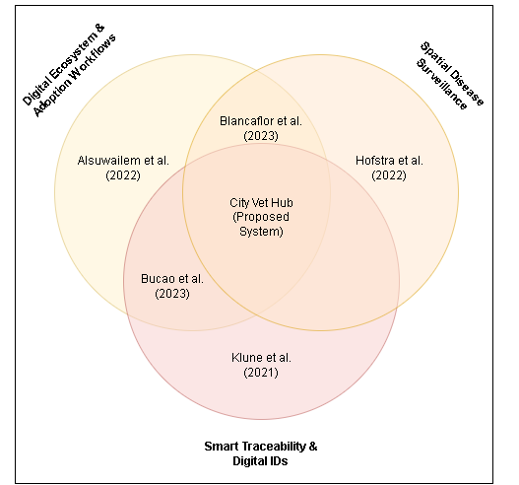
Figure 2.1 Summary of Related Studies
The review of related studies in Chapter 2 demonstrates significant advancements in specific areas of veterinary technology, yet reveals a critical gap in holistic, municipal-level integration. Current research has made distinct progress within isolated domains. For instance, Alsuwailem et al. (2022) successfully explored digital ecosystems and adoption workflows to digitize the pet adoption process and connect communities with care organizations. In parallel, Hofstra et al. (2022) highlighted the critical role of spatial disease surveillance and tracking technologies to dynamically observe animal populations for public health monitoring. Furthermore, Klune et al. (2021) emphasized the importance of smart traceability and digital identification methods to reliably trace lost pets and replace fragmented, paper based records.

While these standalone operational tools are valuable, researchers have only just begun to bridge these individual systems. Blancaflor et al. (2023) made strides by intersecting digital ecosystems with spatial disease surveillance, whereas Bucao et al. (2023) focused on combining adoption workflows with smart traceability and digital IDs. Despite these overlapping capabilities, a distinct technological gap remains: existing systems still lack the complete, real-time data integration across all domains required for local authorities to seamlessly manage populations, facilitate adoptions, and respond to health crises promptly.

Therefore, as illustrated in the summary of related studies, there is an absence of a truly unified platform. The proposed City Vet Hub addresses this exact limitation by positioning itself at the center of these research areas. It converges the digital adoption workflows explored by Alsuwailem et al., the spatial disease surveillance emphasized by Hofstra et al., and the smart traceability championed by Klune et al. alongside the intersectional groundwork laid by Blancaflor et al. and Bucao et al. into a single, centralized web and mobile ecosystem designed specifically for the Iligan City Veterinary Office.

Chapter 3

RESEARCH METHODS
This section describes the materials used and the procedures involved in developing and implementing the proposed system.

Analysis Modeling
Architectural Framework
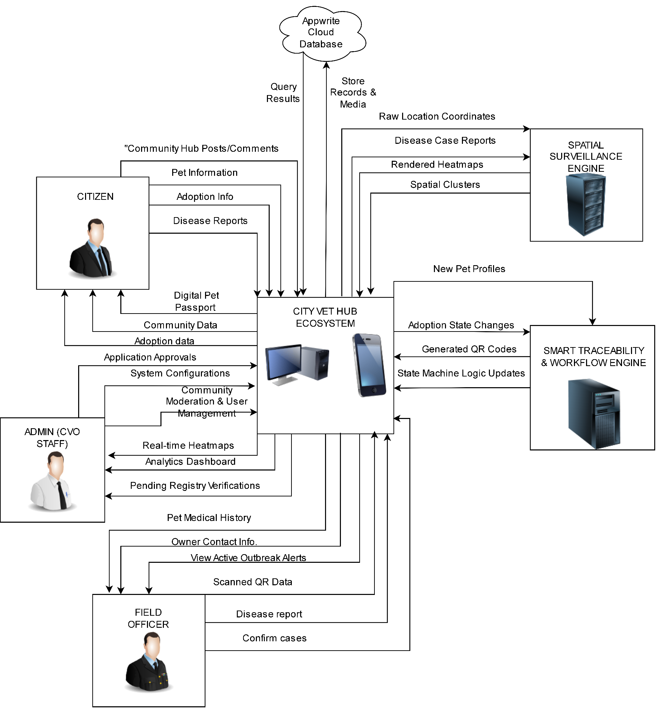
Figure 3.1 Architectural Framework
Figure 3.1 illustrates the Architectural framework of the City Vet Hub, detailing the flow of data between end-users, the central application ecosystem, and the spatial processing engine. At the core of the architecture is the Appwrite.io backend ecosystem, which serves as the central bridge connecting the web and mobile interfaces to the cloud database, facilitating the storage of records and media while retrieving active query results. Operating natively within this central ecosystem is a direct-posting adoption management module and a community hub. The system empowers citizens to upload pets for peer-to-peer adoption and engage in community discussions, while admin-promoted field officers and CVO administrators can also list rescued pets on the public feed. The left side maps the actors: Citizens, Field Officers, and CVO Admins. Citizens register pets, scan QR codes, list pets for adoption, and submit disease incident reports without accessing the restricted spatial heatmaps. Field Officers utilize the system for advanced operations, including viewing spatial heatmaps, looking up municipal pet records, and receiving outbreak alerts. CVO Administrators possess the highest level of access, encompassing all field officer capabilities alongside full moderation controls, such as banning users, moderating community posts, and direct database management. On the right side, complex geographic data processing is offloaded to the Spatial Surveillance Engine. This engine ingests raw location coordinates and disease case reports from the central hub, employing Kernel Density Estimation (KDE) to return visually rendered heatmaps, and Density-Based Spatial Clustering of Applications with Noise (DBSCAN) to automatically identify and return spatial clusters back to the ecosystem for outbreak detection.

Process Flow Diagram
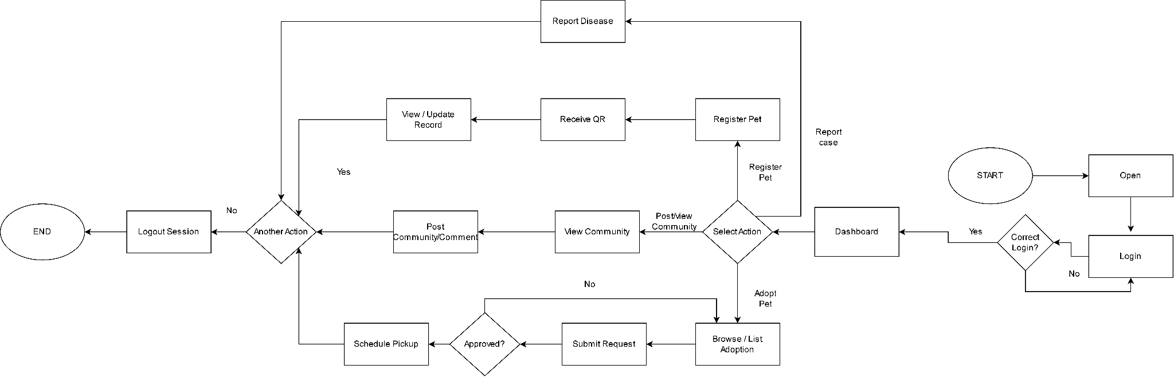

Figure 3.2.1 Citizen Process Flow Diagram
The Citizen User process flow shows how an individual living in Iligan City could execute actions through the mobile application. Starting from opening the app and signing in, after successful verification, the individual navigates to the dashboard page, and at the decision node, he/she can make one of the three decisions. In case he/she makes a decision to “Register Pet,” he/she inputs his/her pet’s data, gets his/her pet a system-generated QR code, and then views and updates his/her pet’s profile. If he/she opts to “View Alert,” he/she can look up on the spatial disease heatmap for the ongoing outbreaks and make reports on strays and disease incidents. Or else if he/she picks “Adopt Pet,” he/she would be allowed to see the available list of the impounded animals and make adoption requests. If his/her request is accepted, he/she will be scheduled to pick up. Finally, the citizen makes a decision to either do anything else or sign out..
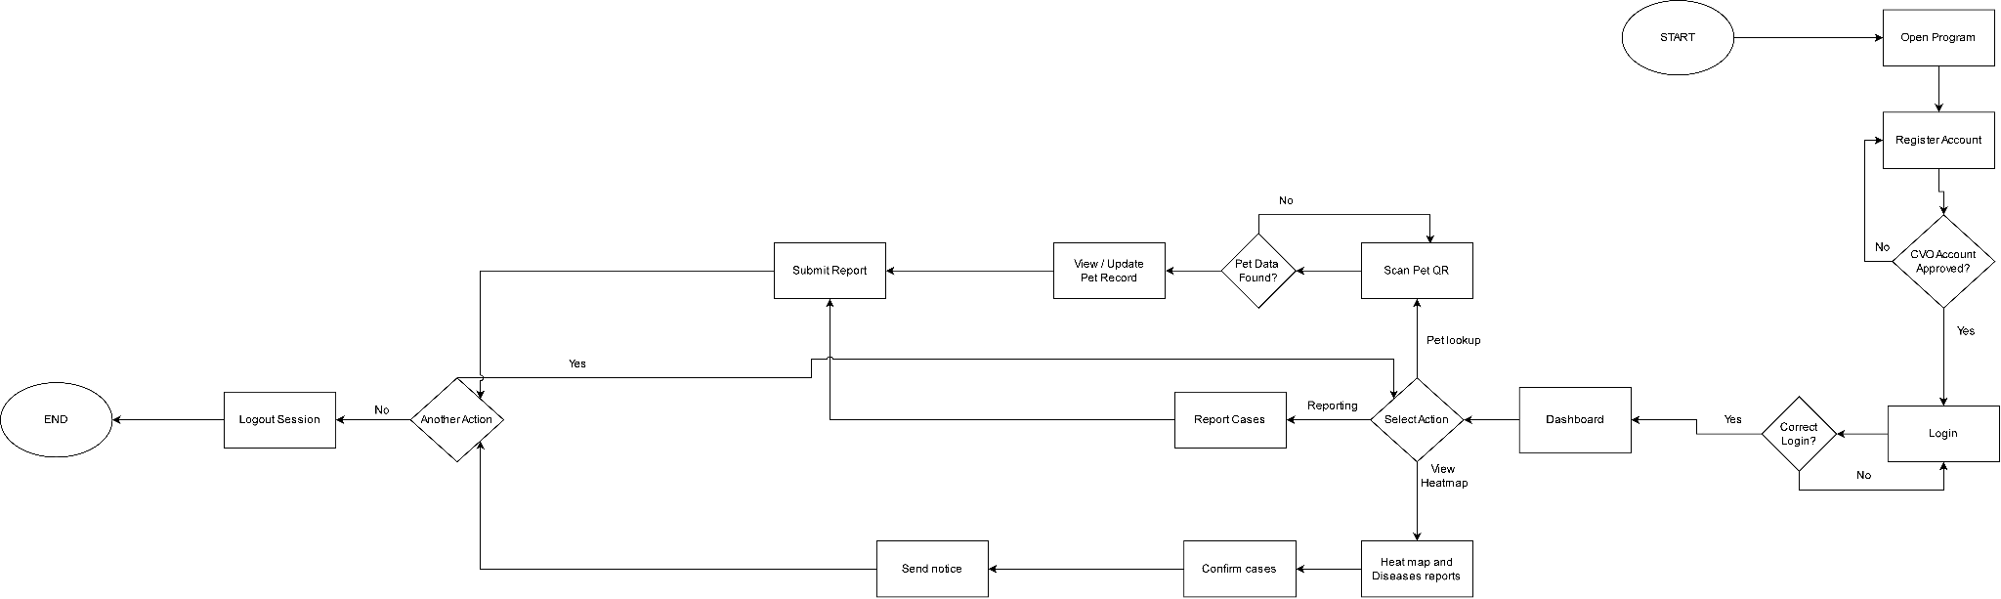
Figure 3.2.2 Field Officer Process Flow Diagram
The Vet process flow provides an overview of the operational processes that ensure that the activities done by the Vet and Field Personnel are secure. Since the process involves sensitive information, the first step in the process is an account registration process that entails obtaining approval from the CVO before access to the site. The user then logs into the system where he or she is taken to a dashboard designed for field operations. The first operational path enables one to scan the QR code of the pet in question; if there are records about the pet in the central database, the vet will access the record and make any necessary updates on the same. The next operational path is known as "Administer Treatment" where the user is able to record the treatment administered to the pet and update its medical history. The third path is known as "Impound Stray" and enables the person in charge of the operation to track the process of rescuing stray animals and take the necessary steps such as updating the records once the owner is located.
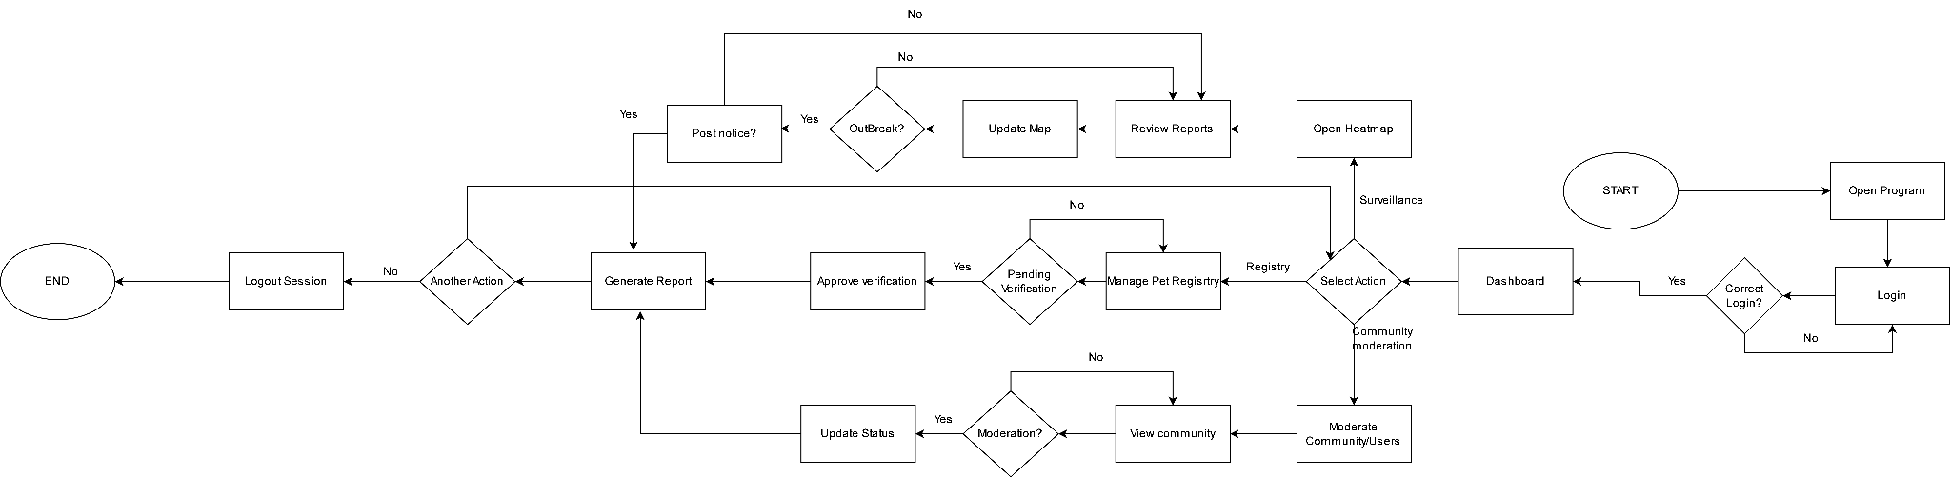
Figure 3.2.23 CVO Staff Process Flow Diagram
The CVO Administrator Process Flow shows how the capabilities behind the Web Administration Panel can be managed. After a successful login procedure, the administrator is faced with a dashboard that includes three main modules. Within the "Surveillance" pathway, the administrator accesses the dynamic heatmap and field reports. At this stage, the system poses an “Outbreak?” decision node. In the event of an outbreak, the administrator sends out a citizen alert and starts the vaccine distribution process. Otherwise, the data in the map will be simply updated. In the “Registry” pathway, the administrator manages pet profiles and pending registrations before finally approving them to generate QR codes. Within the “Adoption Requests” pathway, the administrator accesses the citizen’s adoption request, validates credentials, and changes the animal’s adoption status if approved. All pathways lead to the "Generate Report" function that keeps logs within the system.
System Design
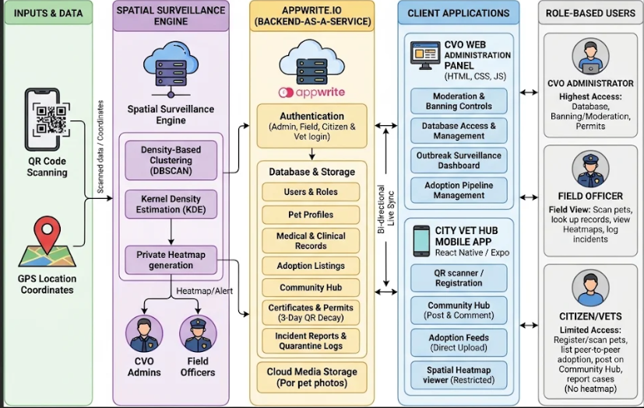
Figure 3.3 System Design
The system design acts as an entire blueprint of the City Vet Hub application development process with the help of the tiered architecture approach. The Presentation Layer includes the Client Mobile Application developed using React Native Expo, and the CVO Web Administration Panels built with standard HTML, CSS, and JavaScript, through which the requests from the clients are sent to the server. Secondly, the Application Layer utilizes Appwrite.io as the backend API gateway to conduct all processing functions including the direct-posting adoption workflow (supporting both peer-to-peer and official CVO listings), community hub interactions, strict role-based authorization separating public reporting from internal heatmap access, and the creation of unique QR codes for traceability purposes. Thirdly, the Data Layer works as the source of persistent data storage and integration processes involving the Appwrite database management system, cloud media storage, and heatmap generation through external map API services.

Entity Relationship Diagram
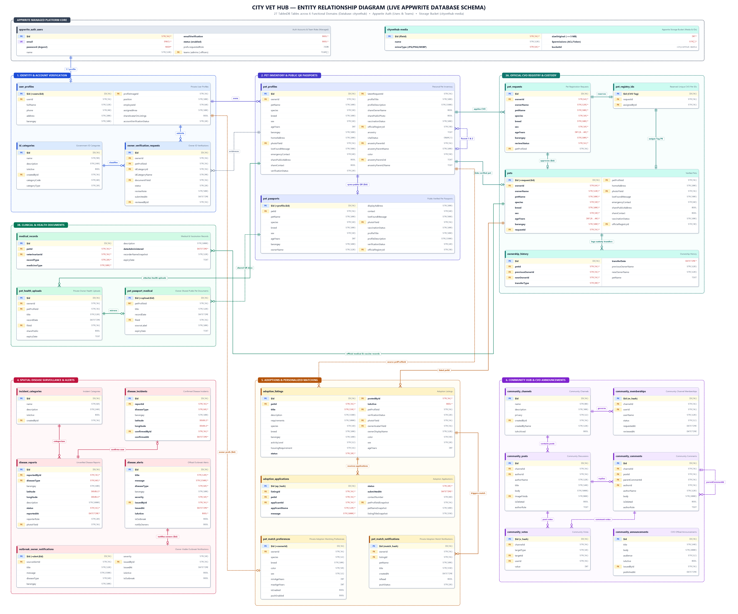

Figure 3.4 Entity Relationship Diagram
Figure 3.4 presents the updated Entity Relationship Diagram (ERD) of the CityVetHub centralized cloud database implemented on Appwrite TablesDB (cityvethub). Unlike the earlier eight-table relational draft, the production architecture comprises 27 normalized database tables organized across six functional domains and integrated with two Appwrite managed platform services: Appwrite Authentication (users accounts and role-based teams cityvethub-admins and cityvethub-field-officers) and Appwrite Storage (bucket cityvethub-media). Rather than maintaining a separate barangay lookup table, all municipal addresses and surveillance coordinates are validated server-side against a canonical list of Iligan City’s 44 barangays (CITY_BARANGAYS) and stored consistently across user, pet, adoption, and disease-tracking tables.

Across the schema, clear security boundaries separate private owner records from public-facing views and official veterinary data. Owner verification workflows link user_profiles and id_categories via owner_verification_requests, while pet ownership separates personal inventory (pet_profiles, including consent toggles and two-parent lineage self-references ancestryParentId and ancestryParent2Id) from CVO verification applications (pet_requests), atomic official tag reservations (pet_registry_ids), verified registry records (pets), and consent-filtered public QR projections (pet_passports and pet_passport_medical). Clinical treatments and vaccinations (medical_records and pet_health_uploads with optional expiration dates), geospatial disease surveillance (incident_categories, disease_reports, disease_incidents, disease_alerts, outbreak_owner_notifications), adoption and smart matching (adoption_listings, adoption_applications, pet_match_preferences, pet_match_notifications), community forums (community_channels, community_memberships, community_posts, community_comments, community_votes, community_announcements), and immutable chain-of-custody logs (ownership_history) maintain referential integrity using Appwrite 36-character string document keys ($id) and deterministic hash identifiers.

Data Dictionary
The tables below document the live Appwrite TablesDB schema (cityvethub) together with the referenced Appwrite platform services. Every database table automatically maintains Appwrite system attributes $id (Primary Key, up to 36 characters), $createdAt, $updatedAt, and row-level security $permissions enforced by the Appwrite server and Cloud Function (cityvethub-operations).
Table 3.1: Appwrite Managed Platform Entities (Auth, Teams & Media Storage)
This table outlines the managed Appwrite Authentication, Team membership, and Object Storage entities referenced by foreign keys across all 27 database tables.
Attribute | Type | Length | Description
users.$id (PK) | STRING | 36 | Serves as the unique account identifier referenced by owner, author, reporter, issuer, and applicant columns across the database.
users.email (UK) | STRING | 160 | Stores the user’s unique email address used for sign-in, email verification, and account management.
users.emailVerification | BOOLEAN | 1 | Indicates whether the registered user has confirmed their email address through the mandatory verification link.
users.status | BOOLEAN | 1 | Controls whether the user account is active, keeping pending Field Officers blocked until a CVO Administrator approves them.
users.prefs.requestedRole | JSON | Variable | Stores the registrant’s chosen role preference ("owner" or "officer") so it can be verified prior to team assignment.
teams.$id (PK) | STRING | 36 | Identifies the Appwrite Team role groups ("cityvethub-admins" and "cityvethub-field-officers") that grant staff permissions and badges.
cityvethub-media.$id (PK) | STRING | 36 | Identifies each uploaded photo or document inside object storage (JPG, PNG, or WEBP up to 5 MB) referenced by file ID columns.

Domain 1: User Identity & Account Verification Tables
Table 3.1.1: user_profiles (Private User Profiles) Table
This table stores personal profile details, staff metadata, residential barangay, and identity verification status for every registered account.
Attribute | Type | Length | Description
$id (PK) | STRING | 36 | Serves as the unique primary key for each user profile and matches the owner’s Appwrite Authentication account ID.
userId (FK) | STRING | 36 | Links the profile record back to the corresponding user account identifier in Appwrite Authentication.
fullName | STRING | 128 | Stores the registered user’s full display name shown across veterinary records, applications, and discussions.
phone | STRING | 40 | Holds the user’s contact phone number so CVO staff or adopters can reach them when needed.
address | STRING | 200 | Contains the street, house number, or purok details of the user’s residential address.
barangay | STRING | 100 | Records the user’s Iligan City barangay, validated server-side against the official list of 44 barangays.
profileImageId (FK) | STRING | 36 | References the user’s uploaded profile picture file stored inside the cityvethub-media bucket.
position | STRING | 100 | States the official job title or designation held by a CVO Administrator or Field Officer.
employeeId | STRING | 60 | Stores the official government or City Veterinary Office employee ID number assigned to staff personnel.
assignedArea | STRING | 100 | Indicates the specific barangay or district coverage area assigned to a Field Officer.
shareAvatarOnListings | BOOLEAN | 1 | Indicates whether the pet owner agrees to display their profile picture on public adoption listings they post.
accountVerificationStatus | STRING | 20 | Tracks whether the pet owner’s identity has been verified by the CVO as unverified, pending, verified, or rejected.

Table 3.1.2: id_categories (Government ID Categories) Table
This table defines the accepted government ID types configured by CVO Administrators for verifying pet owner accounts.
Attribute | Type | Length | Description
$id (PK) | STRING | 36 | Serves as the unique identifier automatically assigned to each accepted government ID category.
name | STRING | 90 | Contains the display name of the accepted government ID type presented to applicants during verification.
description | STRING | 240 | Provides helpful submission instructions or acceptability guidelines to help pet owners upload a valid ID.
isActive | BOOLEAN | 1 | Indicates whether this government ID option is currently active and available for applicants to choose.
createdById (FK) | STRING | 36 | Identifies the CVO Administrator account that created or configured this ID category.
categoryCode | STRING | 40 | Holds a short standardized code used internally to identify the government ID category.
categoryType | STRING | 20 | Specifies whether this identification document falls under the Primary or Secondary ID classification tier.

Table 3.1.3: owner_verification_requests (Private Pet Owner Account Verification Requests) Table
This table tracks identity verification requests submitted by pet owners along with their supporting government ID uploads and review notes.
Attribute | Type | Length | Description
$id (PK) | STRING | 36 | Serves as the unique identifier assigned to each owner identity verification submission.
ownerId (FK) | STRING | 36 | Identifies the pet owner account that submitted the request to verify their identity.
petProfileId (FK) | STRING | 36 | References a pet profile belonging to the applicant to confirm active pet ownership at the time of submission.
idCategoryId (FK) | STRING | 36 | Links the submission to the selected government ID category record in the id_categories table.
idCategoryName | STRING | 90 | Preserves the name of the selected government ID category at the moment the owner submitted their request.
documentFileId (FK) | STRING | 36 | References the private government ID photo uploaded to the cityvethub-media storage bucket for CVO review.
status | STRING | 20 | Tracks the current review outcome of the verification submission as pending, approved, or rejected.
reviewNote | STRING | 500 | Contains optional feedback or a rejection explanation written by the reviewing CVO Administrator.
submittedAt | DATETIME | ISO-8601 | Records the exact date and time when the pet owner submitted the verification request.
reviewedById (FK) | STRING | 36 | Identifies the CVO Administrator account that reviewed and decided on the owner’s verification request.

Domain 2: Personal Pet Inventory & Public QR Passport Tables
Table 3.1.4: pet_profiles (Personal Pet Inventory) Table
This table acts as the owner-managed personal pet inventory containing biological attributes, vital status, two-parent lineage links, and QR privacy toggles.
Attribute | Type | Length | Description
$id (PK) | STRING | 36 | Serves as the unique identifier assigned to each personal pet profile.
ownerId (FK) | STRING | 36 | Identifies the registered pet owner account that currently manages this personal pet profile.
petName | STRING | 100 | Stores the name given to the pet by its owner or registered with the City Veterinary Office.
species | STRING | 10 | Specifies whether the animal is classified as a Dog or a Cat.
breed | STRING | 100 | Describes the pet’s specific breed, mixed lineage, or local classification such as Aspin or Puspin.
sex | STRING | 10 | Records the biological sex of the pet as Male or Female.
ageYears | INTEGER | 64-bit | Holds the pet’s current or estimated age measured in years.
barangay | STRING | 100 | Indicates the Iligan City barangay where the pet currently resides.
homeAddress | STRING | 200 | Stores the household street address for the pet, which remains hidden unless the owner consents to share it publicly.
photoFileId (FK) | STRING | 36 | References the pet’s portrait image file stored inside the cityvethub-media bucket.
lostFoundMessage | STRING | 500 | Holds a custom recovery note from the owner that appears when someone scans a lost pet’s QR code.
emergencyContact | STRING | 60 | Stores the owner’s emergency contact phone number displayed on QR scans when public sharing is enabled.
sharePublicAddress | BOOLEAN | 1 | Indicates whether the owner permits showing the household street address on the pet’s public QR passport page.
shareContact | BOOLEAN | 1 | Indicates whether the owner permits displaying their emergency contact number on public QR passport scans.
verificationStatus | STRING | 20 | Tracks whether this pet profile is a draft, awaiting CVO review, officially verified, or rejected.
latestRequestId (FK) | STRING | 36 | Points to the most recent CVO registration application submitted for this pet profile.
profileTitle | STRING | 100 | Stores an optional custom headline displayed at the top of the pet’s public QR profile.
profileDescription | STRING | 1500 | Contains the owner’s short biography, temperament description, or special care instructions for the pet.
shareOwnerName | BOOLEAN | 1 | Indicates whether the owner chooses to reveal their full name on public QR passport scans.
sharePublicPhoto | BOOLEAN | 1 | Indicates whether the pet’s portrait photo is allowed to be publicly viewed on the QR passport page.
vaccinationStatus | STRING | 100 | Summarizes the pet’s latest vaccination status synced from official veterinary medical records.
officialRegistryId (FK) | STRING | 30 | Links the profile to the official CVO pet registry tag reserved for this animal upon approval.
ancestry | TEXT | Variable | Preserves free-text family lineage notes retained for backwards compatibility with older pet records.
vitalStatus | ENUM | 3 values | Indicates the pet’s current living condition as Alive, Deceased, or Missing.
ancestryParentId (FK) | STRING | 36 | References an optional first parent pet profile in the database to build a verified, loop-free family tree.
ancestryParentName | STRING | 100 | Saves the display name of the first listed parent pet so lineage details load quickly without extra lookups.
color | STRING | 50 | Describes the pet’s primary coat or fur color to support searching and automated adoption matching.
ancestryParent2Id (FK) | TEXT | Variable | References an optional second distinct parent pet profile in the database to record two-parent ancestry.
ancestryParent2Name | TEXT | Variable | Saves the display name of the second listed parent pet for immediate lineage display on the profile.

Table 3.1.5: pet_passports (Public Verified Pet Passports) Table
This table provides a consent-filtered, publicly readable projection displayed whenever someone scans a pet’s QR code.
Attribute | Type | Length | Description
$id (PK) | STRING | 36 | Serves as the public QR passport key, synchronized one-to-one with the corresponding personal pet profile or legacy pet ID.
petId (FK) | STRING | 36 | Links the public QR passport back to the originating pet profile, verified registry record, or request ID.
petName | STRING | 100 | Displays the pet’s name to anyone scanning its public QR passport.
species | STRING | 10 | Displays the animal’s species classification, such as Dog or Cat, on the public passport.
breed | STRING | 100 | Shows the pet’s registered breed on its public QR profile page.
sex | STRING | 10 | Displays the pet’s biological sex on the public passport view.
ageYears | INTEGER | 64-bit | Shows the pet’s listed age in years to QR scanners.
barangay | STRING | 100 | Displays the pet’s residential barangay within Iligan City without exposing private street details.
ownerName | STRING | 128 | Shows the owner’s name only when public name sharing is enabled, and remains blank otherwise to protect privacy.
displayAddress | STRING | 200 | Displays the pet’s street address only when the owner has opted into sharing it publicly.
contact | STRING | 60 | Displays the owner’s emergency contact phone number only when contact sharing consent is turned on.
lostFoundMessage | STRING | 500 | Shows the owner’s recovery instructions when a finder scans the pet’s QR tag.
photoFileId (FK) | STRING | 36 | References the pet’s photo file in cityvethub-media only when the owner has consented to make the photo public.
vaccinationStatus | STRING | 100 | Presents a public summary confirming whether the pet has active or recorded vaccinations.
profileTitle | STRING | 100 | Displays the owner-written custom headline synced from the personal pet profile.
profileDescription | STRING | 1500 | Shows the owner’s public notes, personality summary, or care instructions for the pet.
verificationStatus | STRING | 20 | Indicates whether the pet displays a CVO Verified badge or remains unverified on the scanned QR page.
officialRegistryId (FK) | STRING | 30 | Displays the official CVO registry tag number assigned to verified pets.

Domain 3: Official CVO Registry, Medical Records & Custody History Tables
Table 3.1.6: pet_requests (Pet Registration Requests) Table
This table stores pet verification requests submitted by citizens while awaiting or completing CVO Administrator review.
Attribute | Type | Length | Description
$id (PK) | STRING | 36 | Serves as the unique identifier assigned to each CVO pet registration application.
ownerId (FK) | STRING | 64 | Identifies the pet owner account submitting the application for official CVO verification.
ownerName | STRING | 128 | Captures the applicant’s display name at the time they submitted the registration request.
petName | STRING | 100 | Contains the name of the pet being submitted for CVO approval.
species | STRING | 10 | Specifies whether the animal submitted for registration is a Dog or a Cat.
breed | STRING | 100 | Identifies the submitted breed or mixed-breed designation of the pet.
sex | STRING | 10 | Records whether the submitted animal is Male or Female.
ageYears | INTEGER | 0–40 | Stores the validated age of the pet between 0 and 40 years at the time of registration.
barangay | STRING | 100 | Specifies the canonical Iligan City barangay where the applicant and pet reside.
reviewStatus | STRING | 16 | Tracks whether the verification application is pending, approved, rejected, or withdrawn.
petProfileId (FK) | STRING | 36 | Links the application back to the owner’s personal pet profile, or remains blank for older mobile submissions.

Table 3.1.7: pet_registry_ids (Reserved Unique CVO Pet IDs) Table
This table reserves unique official CVO registry tags atomically during registration approval.
Attribute | Type | Length | Description
$id (PK) | STRING | 36 | Stores the uppercase alphanumeric official CVO Pet Tag assigned to an approved pet so duplicate tags can never be issued concurrently.
requestId (FK) | STRING | 36 | References the approved pet registration request that claimed this unique official CVO tag.
assignedById (FK) | STRING | 36 | Identifies the CVO Administrator account that approved the registration and issued the tag.

Table 3.1.8: pets (Verified Pets) Table
This table holds CVO-verified animal records accessed by staff and owners for clinical treatments, official tag lookups, and custody transfers.
Attribute | Type | Length | Description
$id (PK) | STRING | 36 | Serves as the official verified pet identifier matching the approved application’s ID in pet_requests.
ownerId (FK) | STRING | 64 | Identifies the verified pet owner who currently holds official custody of the animal.
ownerName | STRING | 128 | Stores the current owner’s display name, which updates automatically whenever custody transfers occur.
petName | STRING | 100 | Contains the pet’s official CVO-registered name.
species | STRING | 10 | Specifies whether the officially registered animal is a Dog or a Cat.
breed | STRING | 100 | Records the pet’s official registered breed classification.
sex | STRING | 10 | Indicates the verified biological sex of the animal as Male or Female.
ageYears | INTEGER | 0–40 | Stores the pet’s validated age in years within the 0 to 40 year range.
barangay | STRING | 100 | Identifies the canonical Iligan City barangay associated with the verified pet’s household.
requestId (FK) | STRING | 36 | References the approved verification application in pet_requests that created this official pet record.
petProfileId (FK) | STRING | 36 | Links the verified registry entry to the corresponding personal pet profile managed by the owner.
homeAddress | STRING | 200 | Stores the verified pet’s street address and is cleared automatically whenever ownership is transferred to protect prior owners.
photoFileId (FK) | STRING | 36 | References the pet’s photo file inside the cityvethub-media storage bucket.
lostFoundMessage | STRING | 500 | Stores an optional recovery notice associated with the verified animal.
emergencyContact | STRING | 60 | Holds the owner’s emergency contact phone number and is cleared upon ownership transfer.
sharePublicAddress | BOOLEAN | 1 | Indicates whether the owner permits displaying the pet’s street address publicly.
shareContact | BOOLEAN | 1 | Indicates whether the owner allows showing their emergency contact number on public pages.
vaccinationStatus | STRING | 100 | Reflects the official vaccination summary updated whenever CVO staff log a new immunization.
officialRegistryId (FK) | STRING | 30 | Stores the unique official CVO tag identifier issued from the pet_registry_ids table.

Table 3.1.9: medical_records (Medical & Vaccination Records) Table
This table records official veterinary vaccinations and medical treatments performed by CVO staff, including optional expiration dates.
Attribute | Type | Length | Description
$id (PK) | STRING | 36 | Serves as the unique identifier assigned to each official vaccination or treatment log.
petId (FK) | STRING | 36 | Links the clinical treatment entry directly to the verified pet treated by veterinary personnel.
veterinarianId (FK) | STRING | 36 | Identifies the CVO Administrator or Field Officer account that recorded or performed the procedure.
recordType | STRING | 20 | Distinguishes whether the clinical entry represents a Vaccination or a general medical Treatment.
medicineType | STRING | 100 | Names the specific vaccine or medication administered to the pet, such as Anti-Rabies or deworming medicine.
description | STRING | 1000 | Holds optional clinical observations, dosage instructions, or remarks entered by veterinary personnel.
dateAdministered | DATETIME | ISO-8601 | Records the date when the vaccine or medical treatment was given to the animal.
recorderNameSnapshot | STRING | 128 | Saves the display name of the veterinarian or officer who logged the procedure for historical attribution.
expiryDate | TEXT | Variable | Records an optional expiration or booster due date indicating when the vaccination or treatment validity ends.

Table 3.1.10: pet_health_uploads (Private Owner Health Uploads) Table
This table stores private vaccination cards and medical photos uploaded by owners along with optional expiry dates.
Attribute | Type | Length | Description
$id (PK) | STRING | 36 | Serves as the unique identifier assigned to each owner-uploaded health document.
ownerId (FK) | STRING | 36 | Identifies the pet owner who uploaded this supporting health document or vaccination card.
petProfileId (FK) | STRING | 36 | Links the uploaded health record to the personal pet profile it belongs to.
title | STRING | 120 | Contains the owner-written title describing the vaccination card, test result, or treatment record.
recordDate | DATETIME | ISO-8601 | Stores the date of the veterinary visit or document recorded by the owner.
fileId (FK) | STRING | 36 | References the scanned image file of the health document inside the cityvethub-media storage bucket.
sharePublic | BOOLEAN | 1 | Indicates whether the owner consented to display this uploaded document publicly on the pet’s QR passport.
expiryDate | TEXT | Variable | Stores an optional expiration date provided by the owner for the uploaded vaccine card or treatment record.

Table 3.1.11: pet_passport_medical (Owner-Shared Public Pet Documents) Table
This table publishes owner-consented health documents onto the public QR pet passport with a clear non-clinician provenance notice.
Attribute | Type | Length | Description
$id (PK) | STRING | 36 | Mirrors the unique identifier of its source record in pet_health_uploads whenever public sharing is enabled, indexed by pet profile ID.
petProfileId (FK, IDX) | STRING | 36 | Links the shared public health document back to the pet profile and passport, indexed for rapid QR lookups.
title | STRING | 120 | Displays the document title mirrored from the owner’s health upload onto the public QR passport.
recordDate | DATETIME | ISO-8601 | Shows the date of the medical or vaccination document on the public passport timeline.
fileId (FK) | STRING | 36 | References the publicly readable image file in cityvethub-media so QR visitors can inspect the uploaded card.
sourceLabel | STRING | 100 | Displays a clear provenance notice stating that the record is owner-supplied rather than clinically verified.
expiryDate | TEXT | Variable | Shows the optional expiration date of the shared vaccination or treatment on the public QR passport.

Table 3.1.12: ownership_history (Ownership History) Table
This table maintains an immutable chain-of-custody log documenting previous owners, receiving owners, pet names, and transfer types.
Attribute | Type | Length | Description
$id (PK) | STRING | 36 | Serves as the unique identifier for each custody transfer record, matching the adoption application ID during adoption handovers.
petId (FK) | STRING | 36 | References the unique identifier of the pet whose ownership changed hands.
previousOwnerId (FK) | STRING | 36 | Identifies the outgoing user account that relinquished custody of the pet.
newOwnerId (FK) | STRING | 36 | Identifies the receiving user account that accepted custody of the pet.
transferType | STRING | 40 | Classifies the custody event as an Adoption, Reclaim, Surrender, or Correction.
transferDate | DATETIME | ISO-8601 | Records the exact date and time when ownership of the pet was officially transferred.
previousOwnerName | STRING | 128 | Preserves the previous owner’s name so audit logs remain easy to read even if accounts change later.
newOwnerName | STRING | 128 | Preserves the receiving owner’s name for clear traceability in ownership history tables.
petName | TEXT | Variable | Stores a snapshot of the pet’s name so ownership history rows display readable names rather than raw IDs.

Domain 4: Spatial Disease Surveillance & Outbreak Alerting Tables
Table 3.1.13: incident_categories (Incident Categories) Table
This table defines the disease and incident classifications managed by CVO Administrators for field and citizen reporting.
Attribute | Type | Length | Description
$id (PK) | STRING | 36 | Serves as the unique identifier assigned to each active disease or incident category.
name | STRING | 60 | Contains the unique disease or incident category label managed by the CVO, such as Rabies.
description | STRING | 240 | Provides reporting guidance or clinical notes explaining when staff or citizens should use this category.
isActive | BOOLEAN | 1 | Indicates whether citizens and field staff can currently select this category when reporting an incident.
createdById (FK) | STRING | 36 | Identifies the CVO Administrator account that added this incident category to the system.

Table 3.1.14: disease_reports (Unverified Disease Reports) Table
This table captures citizen and staff disease incident reports along with validated Philippine coordinates, triage status, and evidence photos.
Attribute | Type | Length | Description
$id (PK) | STRING | 36 | Serves as the unique identifier assigned to each geotagged disease incident submission.
reportedById (FK) | STRING | 36 | Identifies the verified pet owner, Field Officer, or Administrator who submitted the disease report.
diseaseType (FK) | STRING | 60 | Specifies the reported disease or incident category matching an active entry in incident_categories.
barangay | STRING | 100 | Records the canonical Iligan City barangay where the suspected or observed case occurred.
latitude | DOUBLE | 64-bit | Stores the pinned GPS latitude coordinate of the report, validated within Philippine geographic bounds.
longitude | DOUBLE | 64-bit | Stores the pinned GPS longitude coordinate of the report, validated within Philippine geographic bounds.
description | STRING | 1000 | Contains a written summary or field observation detailing the symptoms and circumstances of the incident.
status | STRING | 16 | Indicates whether the report is currently active in the triage queue (pending) or moved to historical records (archived).
reportedAt | DATETIME | ISO-8601 | Records the exact timestamp when the incident report was filed.
reporterRole | STRING | 20 | Preserves the role of the submitter at reporting time (admin, officer, or owner) for triage filtering.
photoFileId (FK) | STRING | 36 | References an optional supporting photo attached to the report inside the cityvethub-media bucket.

Table 3.1.15: disease_incidents (Confirmed Disease Incidents) Table
This table preserves legacy confirmed disease coordinates queried when generating long-term spatial surveillance heatmaps.
Attribute | Type | Length | Description
$id (PK) | STRING | 36 | Serves as the unique identifier assigned to each historical confirmed disease incident entry.
reportId (FK) | STRING | 36 | Links the confirmed case entry back to its originating submission in the disease_reports table.
diseaseType | STRING | 60 | Records the classified disease or incident label for the confirmed case.
barangay | STRING | 100 | Identifies the canonical Iligan City barangay where the confirmed case is located.
latitude | DOUBLE | 64-bit | Stores the confirmed GPS latitude coordinate used in spatial heatmap and clustering calculations.
longitude | DOUBLE | 64-bit | Stores the confirmed GPS longitude coordinate used in spatial heatmap and clustering calculations.
confirmedById (FK) | STRING | 36 | Identifies the veterinary staff member who confirmed the disease incident.
confirmedAt | DATETIME | ISO-8601 | Records the exact timestamp when the disease case was officially confirmed.

Table 3.1.16: disease_alerts (Official Outbreak Alerts) Table
This table stores official CVO outbreak declarations and severity advisories visible to veterinary administrators and Field Officers.
Attribute | Type | Length | Description
$id (PK) | STRING | 36 | Serves as the unique identifier assigned to each official CVO disease alert or outbreak declaration.
title | STRING | 120 | Contains the headline of the official alert or outbreak declaration issued by the City Veterinary Office.
message | STRING | 1500 | Provides the detailed public health warning, containment advice, or response instructions for the alert.
diseaseType | STRING | 60 | Identifies the specific disease or incident category targeted by the advisory or outbreak notice.
barangay | STRING | 100 | Specifies the affected Iligan City barangay covered by the alert or outbreak declaration.
severity | STRING | 10 | Categorizes the urgency level of the alert as low, medium, or high.
issuedById (FK) | STRING | 36 | Identifies the CVO Administrator who published the alert or declared the outbreak.
issuedAt | DATETIME | ISO-8601 | Records the date and time when the alert was officially issued.
isActive | BOOLEAN | 1 | Indicates whether the alert is currently active or has been deactivated and archived.
isOutbreak | BOOLEAN | 1 | Distinguishes whether the alert is a formal barangay outbreak declaration or a general health advisory.
notifyOwners | BOOLEAN | 1 | Indicates whether a citizen-friendly copy should be published to pet owners in outbreak_owner_notifications.

Table 3.1.17: outbreak_owner_notifications (Owner-visible CVO outbreak and health notifications) Table
This table delivers active CVO outbreak warnings and public health advisories directly into pet owners’ notification feeds.
Attribute | Type | Length | Description
$id (PK) | STRING | 36 | Synchronizes its unique identifier one-to-one with the originating alert in disease_alerts when owner notifications are enabled.
sourceAlertId (FK) | STRING | 36 | Links the owner-facing notification back to the original alert row in the disease_alerts table.
title | STRING | 120 | Displays the advisory or outbreak headline shown in the pet owner’s notification feed.
message | STRING | 1500 | Provides clear precautionary steps and public health guidance written for pet owners.
diseaseType | STRING | 60 | Names the disease or incident category associated with the health notification.
barangay | STRING | 100 | Identifies the affected Iligan City barangay highlighted by the notification.
severity | STRING | 10 | Indicates the alert severity level (low, medium, or high) to help owners gauge urgency.
issuedById (FK) | STRING | 36 | Identifies the CVO Administrator who issued the underlying health advisory.
issuedAt | DATETIME | ISO-8601 | Records the timestamp when the owner notification was published.
isActive | BOOLEAN | 1 | Keeps the notification visibility synchronized with the active status of the source alert.
isOutbreak | BOOLEAN | 1 | Indicates whether the notice reflects a formal barangay outbreak or a general precaution.

Domain 5: Pet Adoptions & Personalized Matching Tables
Table 3.1.18: adoption_listings (Adoption Listings) Table
This table manages active and reserved CVO Official and peer-to-peer adoption posts along with matching attributes and photo consent.
Attribute | Type | Length | Description
$id (PK) | STRING | 36 | Serves as the unique identifier for each adoption listing, matching the pet’s ID for CVO Official posts.
petId (FK) | STRING | 36 | References either the verified CVO pet record or the personal pet profile featured for adoption.
title | STRING | 150 | Contains the headline shown on the pet’s card in the public Adoption Hub.
description | STRING | 1500 | Shares the pet’s background story, temperament, and rehoming notes for prospective adopters.
requirements | STRING | 1000 | Lists specific adopter expectations or home requirements set by the pet owner or CVO.
species | STRING | 10 | Specifies the pet’s species (Dog or Cat) for search filters and automated adopter matching.
breed | STRING | 100 | Identifies the pet’s breed to support browse filters and personalized adoption match alerts.
barangay | STRING | 100 | Indicates the Iligan City barangay where the adoptable pet is currently located.
activityLevel | STRING | 12 | Describes the pet’s typical energy and activity level, defaulting to medium when unspecified.
housingRequirement | STRING | 16 | Specifies the ideal adopter living arrangement, such as any, apartment, house, or yard.
status | STRING | 20 | Tracks whether the pet is currently available for adoption, reserved for an applicant, or already adopted.
postedById (FK) | STRING | 36 | Identifies the pet owner or CVO Administrator account that published the adoption listing.
isActive | BOOLEAN | 1 | Controls whether the listing currently appears in the active Adoption Hub directory.
petProfileId (FK) | STRING | 36 | Links the adoption listing directly to the pet’s personal inventory record in pet_profiles.
verificationStatus | STRING | 20 | Displays whether the listed pet holds CVO verification or remains an owner-submitted listing.
photoFileId (FK) | STRING | 36 | References the pet’s publicly shared photo file stored in cityvethub-media.
ownerAvatarFileId (FK) | STRING | 36 | References the listing owner’s avatar image in cityvethub-media when avatar sharing consent is enabled.
ownerDisplayName | STRING | 128 | Shows either the consenting pet owner’s name or the label "CVO Official Listing".
color | STRING | 50 | Records the pet’s primary coat color synced from its profile so smart adoption matching can compare preferences.
sex | STRING | 20 | Displays the pet’s biological sex (Male or Female) for filtering and adopter matching.
ageYears | INTEGER | 64-bit | Stores the pet’s age in years so adopters can filter and match within their preferred age range.

Table 3.1.19: adoption_applications (Adoption Applications) Table
This table tracks prospective adopter requests, owner decisions, contact numbers, and preserved snapshot details after handover.
Attribute | Type | Length | Description
$id (PK) | STRING | 36 | Uses a deterministic hash identifier generated from the listing and applicant IDs so each user can submit only one application per listing.
listingId (FK) | STRING | 36 | References the specific adoption listing that the user is applying to adopt from.
petId (FK) | STRING | 36 | Links the application to the pet featured in the target adoption listing.
applicantId (FK) | STRING | 36 | Identifies the user account of the prospective adopter who submitted the application.
applicantName | STRING | 128 | Captures the applicant’s display name at the time they submitted their adoption request.
message | STRING | 1000 | Contains the applicant’s personal introduction, home environment summary, and reason for adopting.
status | STRING | 20 | Tracks the application outcome through pending, approved, rejected, or completed handover states.
submittedAt | DATETIME | ISO-8601 | Records the exact date and time when the adoption application was sent.
contactNumber | STRING | 40 | Stores the applicant’s validated phone number so the current owner or CVO can coordinate pickup.
petProfileIdSnapshot | STRING | 36 | Preserves the adopted pet’s profile ID so completed applications remain linked even after the listing closes.
petNameSnapshot | STRING | 100 | Saves the pet’s name inside the application record so history screens stay readable after adoption completion.
listingTitleSnapshot | STRING | 150 | Preserves the original adoption post headline after the active listing is archived or removed.

Table 3.1.20: pet_match_preferences (Private Adoption Matching Preferences) Table
This table saves each user’s personalized species, breed, color, sex, age range, and push-notification criteria for adoption matching.
Attribute | Type | Length | Description
$id (PK) | STRING | 36 | Serves as the unique preference record key matching the subscribing pet owner’s user ID.
ownerId (FK) | STRING | 36 | Links the preference profile back to the pet owner account that configured the matching filters.
species | STRING | 12 | Specifies the user’s preferred species to adopt, such as Any, Dog, or Cat.
breed | STRING | 100 | Holds an optional preferred breed name, or remains empty to match pets of any breed.
color | STRING | 50 | Holds an optional preferred coat color, or remains empty to match pets of any color.
sex | STRING | 12 | Specifies the user’s preferred pet sex as Any, Male, or Female.
minAgeYears | INTEGER | 64-bit | Sets the minimum pet age in years (from 0 to 40) that should trigger a match notification.
maxAgeYears | INTEGER | 64-bit | Sets the maximum pet age in years (from 0 to 40) allowed when evaluating new adoption listings.
isEnabled | BOOLEAN | 1 | Indicates whether automatic comparison against newly published adoption listings is turned on for this user.
pushEnabled | BOOLEAN | 1 | Indicates whether the user has opted in to receive Appwrite push notifications when a new match appears.

Table 3.1.21: pet_match_notifications (Private Adoption Match Notifications) Table
This table records automated match notifications generated whenever a newly published adoption listing satisfies a user’s criteria.
Attribute | Type | Length | Description
$id (PK) | STRING | 36 | Uses a deterministic hash identifier generated from the owner and listing IDs so duplicate alerts are never created for the same match.
ownerId (FK) | STRING | 36 | Identifies the user account that received the automated adoption match notification.
listingId (FK) | STRING | 36 | References the newly posted adoption listing that satisfied the user’s saved preferences.
petName | STRING | 100 | Stores a snapshot of the matched pet’s name for immediate display inside the notifications panel.
title | STRING | 150 | Contains the matched adoption listing headline shown inside the notification item.
createdAt | DATETIME | ISO-8601 | Records the timestamp when the automated matching engine generated the notification.
isRead | BOOLEAN | 1 | Tracks whether the user has already opened or dismissed the match notification.
pushStatus | STRING | 20 | Records the mobile push delivery state as pending, sent, failed, or not_requested.

Domain 6: Community Hub & Official Announcements Tables
Table 3.1.22: community_channels (Community Channels) Table
This table organizes public and private discussion channels created by verified Pet Owners, Field Officers, and CVO Administrators.
Attribute | Type | Length | Description
$id (PK) | STRING | 36 | Serves as the unique identifier assigned to each community discussion channel.
name | STRING | 80 | Stores the unique active title (1 to 80 characters) identifying a community discussion channel.
description | STRING | 300 | Explains the discussion topic, purpose, or participation guidelines for members of the channel.
privacy | STRING | 12 | Specifies whether anyone can join freely (public) or whether new members require approval (private).
createdById (FK) | STRING | 36 | Identifies the verified Pet Owner, Field Officer, or CVO Administrator who created the channel.
createdByName | STRING | 128 | Stores a snapshot of the channel creator’s display name at the time the channel was founded.
isArchived | BOOLEAN | 1 | Indicates whether the channel has been archived so inactive channels can be hidden from active lists.

Table 3.1.23: community_memberships (Community Channel Memberships) Table
This table manages join requests and approval statuses for private community discussion channels.
Attribute | Type | Length | Description
$id (PK) | STRING | 36 | Uses a deterministic hash identifier built from the channel and user IDs to prevent duplicate membership entries.
channelId (FK) | STRING | 36 | References the community channel that the user requested or was approved to join.
userId (FK) | STRING | 36 | Identifies the user account seeking or holding membership inside the private channel.
userName | STRING | 128 | Stores the community member’s display name for channel moderation and roster views.
status | STRING | 12 | Tracks the private channel membership request as pending, approved, or rejected.
requestedAt | DATETIME | ISO-8601 | Records the timestamp when the user submitted their request to join the channel.
reviewedAt | DATETIME | ISO-8601 | Records the timestamp when the channel creator or a CVO Administrator acted on the request.

Table 3.1.24: community_posts (Community Discussions) Table
This table stores community discussion posts, multi-image attachment lists, verified staff role badges, and moderation delete flags.
Attribute | Type | Length | Description
$id (PK) | STRING | 36 | Serves as the unique identifier assigned to each discussion thread posted in a channel.
channelId (FK) | STRING | 36 | Links the discussion thread to the community channel where it was published.
authorId (FK) | STRING | 36 | Identifies the user account that authored the community discussion thread.
authorName | STRING | 128 | Displays the author’s name, annotated server-side with an Admin or Field Officer badge for verified personnel.
title | STRING | 140 | Contains the discussion post headline (1 to 140 characters) shown in the community feed.
body | STRING | 5000 | Stores the full post content (up to 5,000 characters), or displays "[Removed]" when deleted during moderation.
imageFileIds (FK[]) | STRING | 800 | Stores a JSON list of up to four uploaded image file IDs from cityvethub-media attached to the post.
isDeleted | BOOLEAN | 1 | Marks whether a post has been soft-deleted while preserving nested comment threads underneath it.
authorRole | TEXT | Variable | Records whether the author posted as an admin, officer, or owner based on Appwrite Team membership.

Table 3.1.25: community_comments (Community Comments) Table
This table stores top-level comments and nested replies linked through parentCommentId alongside verified staff role tags.
Attribute | Type | Length | Description
$id (PK) | STRING | 36 | Serves as the unique identifier assigned to each comment or nested reply.
channelId (FK) | STRING | 36 | Links the comment to the parent channel to allow fast channel-wide loading and moderation.
postId (FK) | STRING | 36 | References the discussion thread in community_posts to which this comment belongs.
parentCommentId (FK) | STRING | 36 | References an earlier comment when replying in a nested thread, or stays blank for top-level comments.
authorId (FK) | STRING | 36 | Identifies the user account that wrote the comment.
authorName | STRING | 128 | Shows the commenter’s display name along with an Admin or Field Officer badge when posted by staff.
body | STRING | 2000 | Stores the comment text (up to 2,000 characters), or displays "[Removed]" if moderated or deleted.
isDeleted | BOOLEAN | 1 | Flags whether the comment has been soft-deleted without breaking child reply hierarchies.
authorRole | TEXT | Variable | Records the commenter’s verified role tag (admin, officer, or owner) at the time of posting.

Table 3.1.26: community_votes (Community Votes) Table
This table records individual community upvotes (+1) and downvotes (-1) on discussion posts and comments.
Attribute | Type | Length | Description
$id (PK) | STRING | 36 | Uses a deterministic hash identifier built from the vote target and user ID so each user gets one active vote per item.
channelId (FK) | STRING | 36 | References the community channel associated with the voted post or comment for score aggregation.
targetType | STRING | 10 | Indicates whether the vote applies to a discussion post or an individual comment.
targetId (FK) | STRING | 36 | Points to either the post ID or comment ID receiving the vote depending on targetType.
userId (FK) | STRING | 36 | Identifies the community member who cast the upvote or downvote.
value | INTEGER | 64-bit | Stores the signed vote score contributed by the user, recorded as +1 for an upvote or -1 for a downvote.

Table 3.1.27: community_announcements (CVO Official Community Announcements) Table
This table stores official City Veterinary Office announcements targeted to pet owners, Field Officers, or both audiences.
Attribute | Type | Length | Description
$id (PK) | STRING | 36 | Serves as the unique identifier assigned to each official CVO community announcement.
title | STRING | 140 | Contains the headline of the official announcement (1 to 140 characters) issued by the City Veterinary Office.
body | STRING | 2000 | Holds the complete announcement message (up to 2,000 characters) shared in the announcement banner and notification feed.
audience | STRING | 12 | Specifies whether the announcement targets pet owners, Field Officers, or both groups simultaneously.
isActive | BOOLEAN | 1 | Indicates whether the announcement is currently visible to users or has been deactivated by an administrator.
issuedById (FK) | STRING | 36 | Identifies the CVO Administrator account that published the official announcement.
publishedAt | DATETIME | ISO-8601 | Records the date and time when the official CVO announcement was published.

The data dictionary entries detailed in Table 3.1 through Table 3.1.27 establish the complete relational structure of the CityVetHub production database on Appwrite. By integrating managed authentication teams and object storage with 27 domain-partitioned tables, the design isolates sensitive citizen identity documents and private pet profiles from public QR passports, coordinates atomic CVO official tag reservation through pet_registry_ids, enforces deterministic hash primary keys to prevent duplicate adoption applications, votes, memberships, and match notifications, and preserves a tamper-evident chain of custody within ownership_history.

Context Diagram
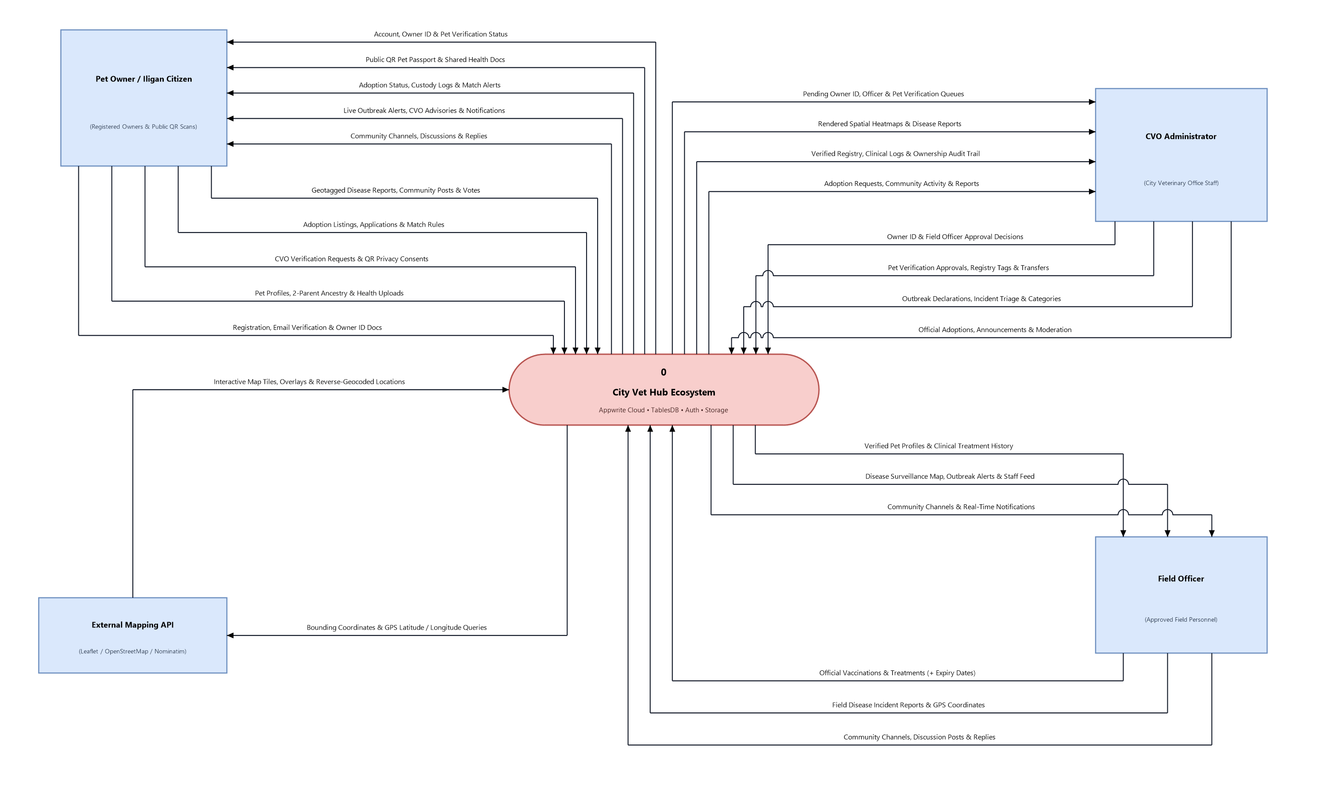

Figure 3.5 Data Flow Diagram Level 0 (Context Diagram)
The Level 0 Data Flow Diagram, also known as the Context Diagram, defines the system boundary of the CityVetHub Ecosystem in relation to external actors and third-party services. It illustrates four external entities interacting with the centralized Appwrite Cloud platform: the Pet Owner / Iligan Citizen, CVO Administrator, Field Officer, and External Mapping API (Leaflet, OpenStreetMap, and Nominatim). The diagram captures the primary bidirectional data flows across the platform, including citizen registration with email verification, owner identity verification requests, personal pet profiles with two-parent ancestry and uploaded health cards, official veterinary vaccinations and treatments with optional expiration dates, spatial disease incident reporting across Iligan City’s 44 barangays, adoption listings with automated matching and ownership custody transfers, and interactive community channels and official advisories—producing consent-filtered public QR pet passports, rendered spatial surveillance heatmaps, and real-time unified in-app notifications.

Data Flow Diagram
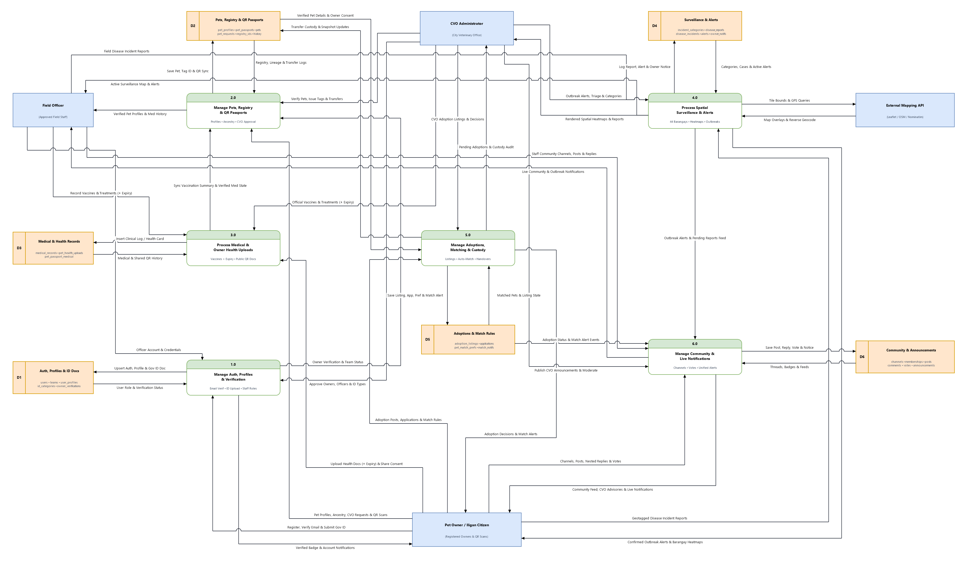

Figure 3.6 Data Flow Diagram Level 1
The Level 1 Data Flow Diagram decomposes the CityVetHub system into six major processes: Manage Auth, Profiles & Verification (1.0), Manage Pets, Registry & QR Passports (2.0), Process Medical & Owner Health Uploads (3.0), Process Spatial Surveillance & Alerts (4.0), Manage Adoptions, Matching & Custody (5.0), and Manage Community & Live Notifications (6.0). It traces how user requests, veterinary clinical actions, geotagged incident reports, and map tile queries move across processes and persist into six domain-grouped data stores (D1 through D6), while feeding inter-process synchronization such as official vaccination summaries, verified ownership handovers, disease outbreak advisories, adoption match alerts, and community discussions into a unified notification center.

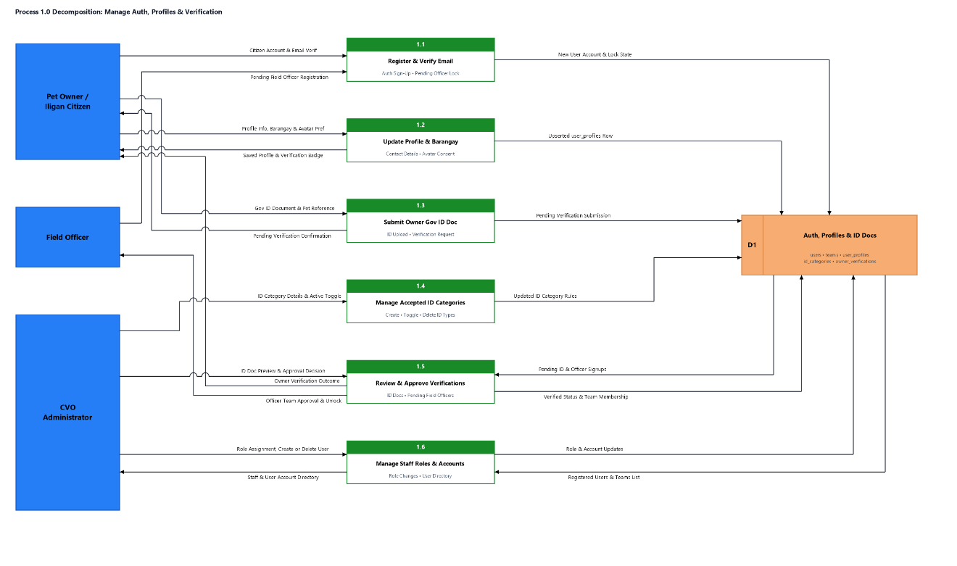
Decomposition
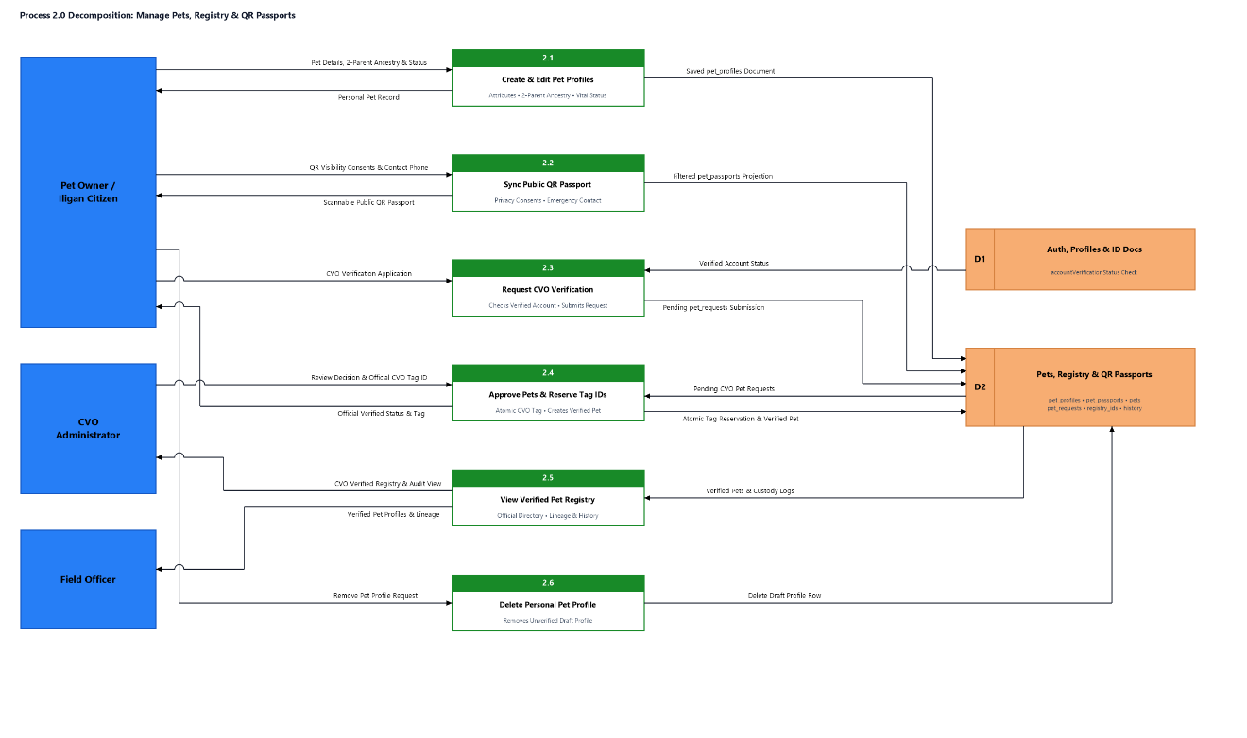
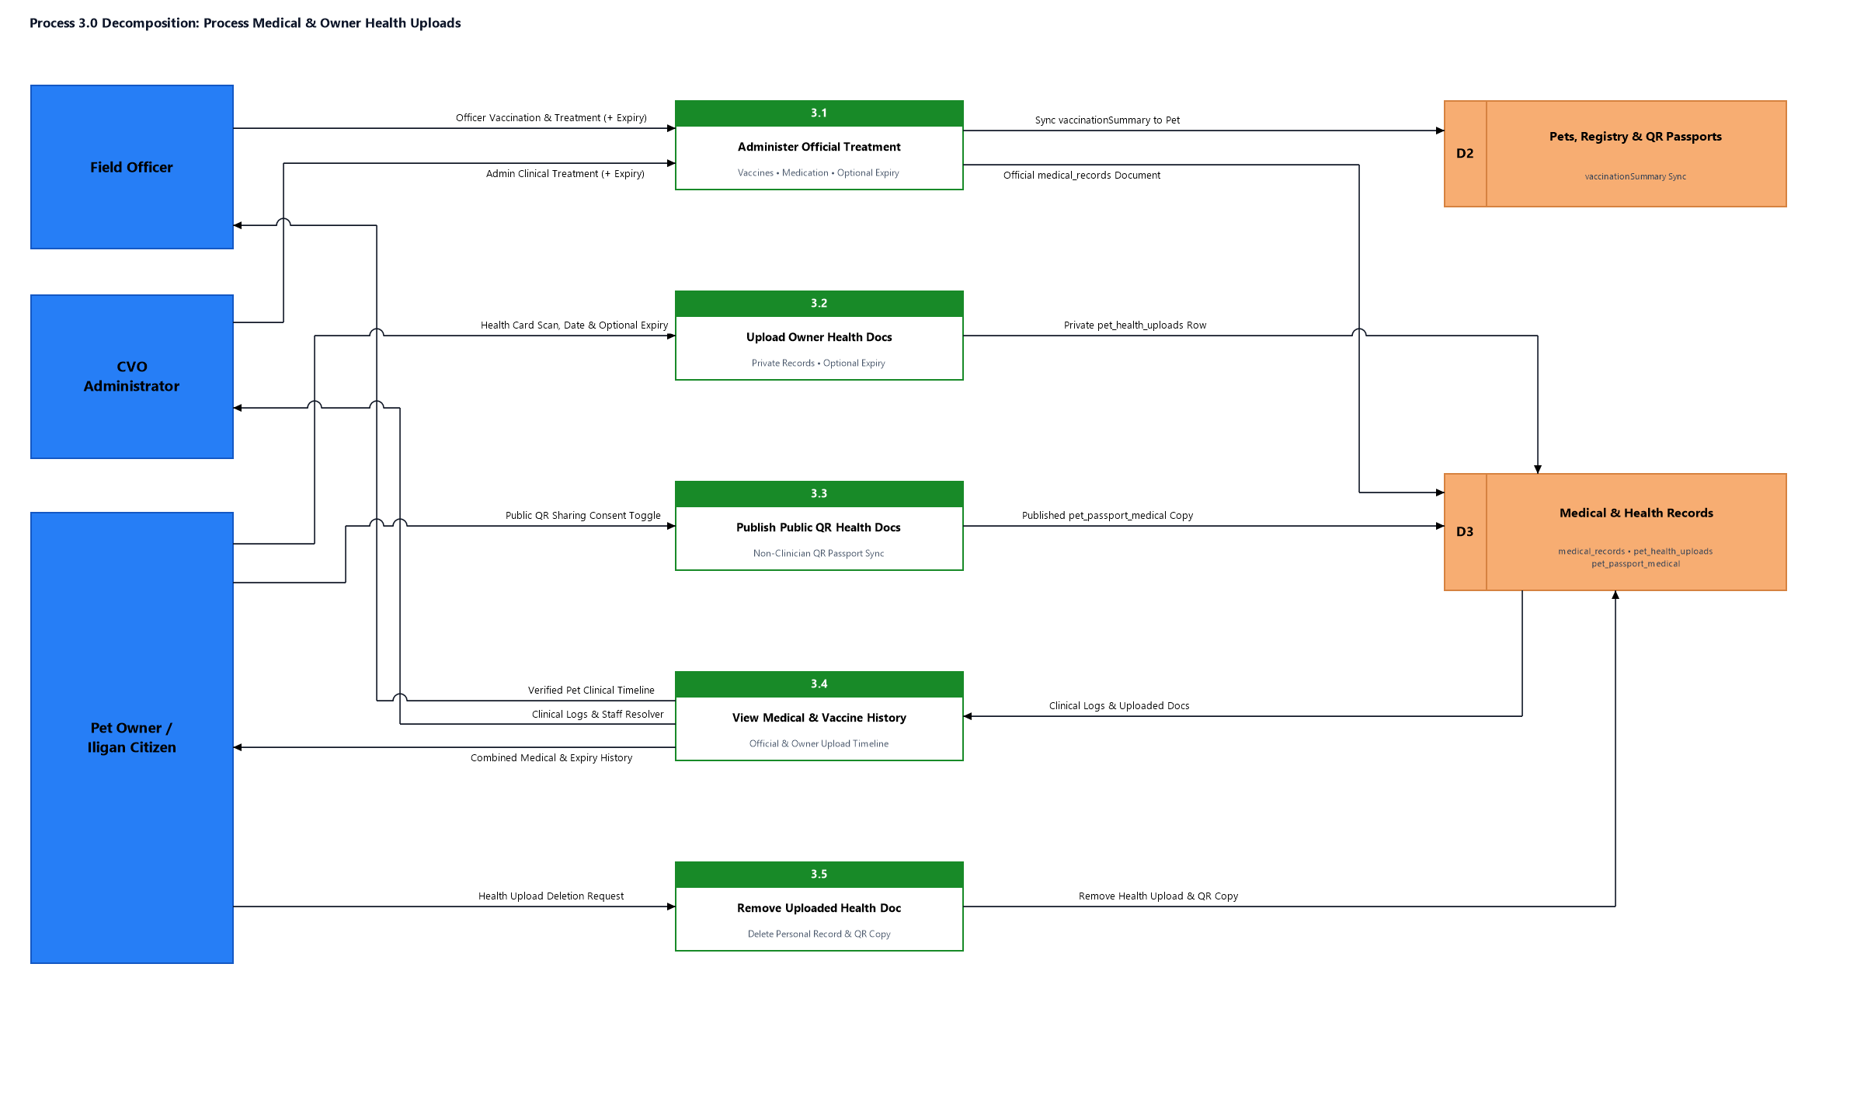
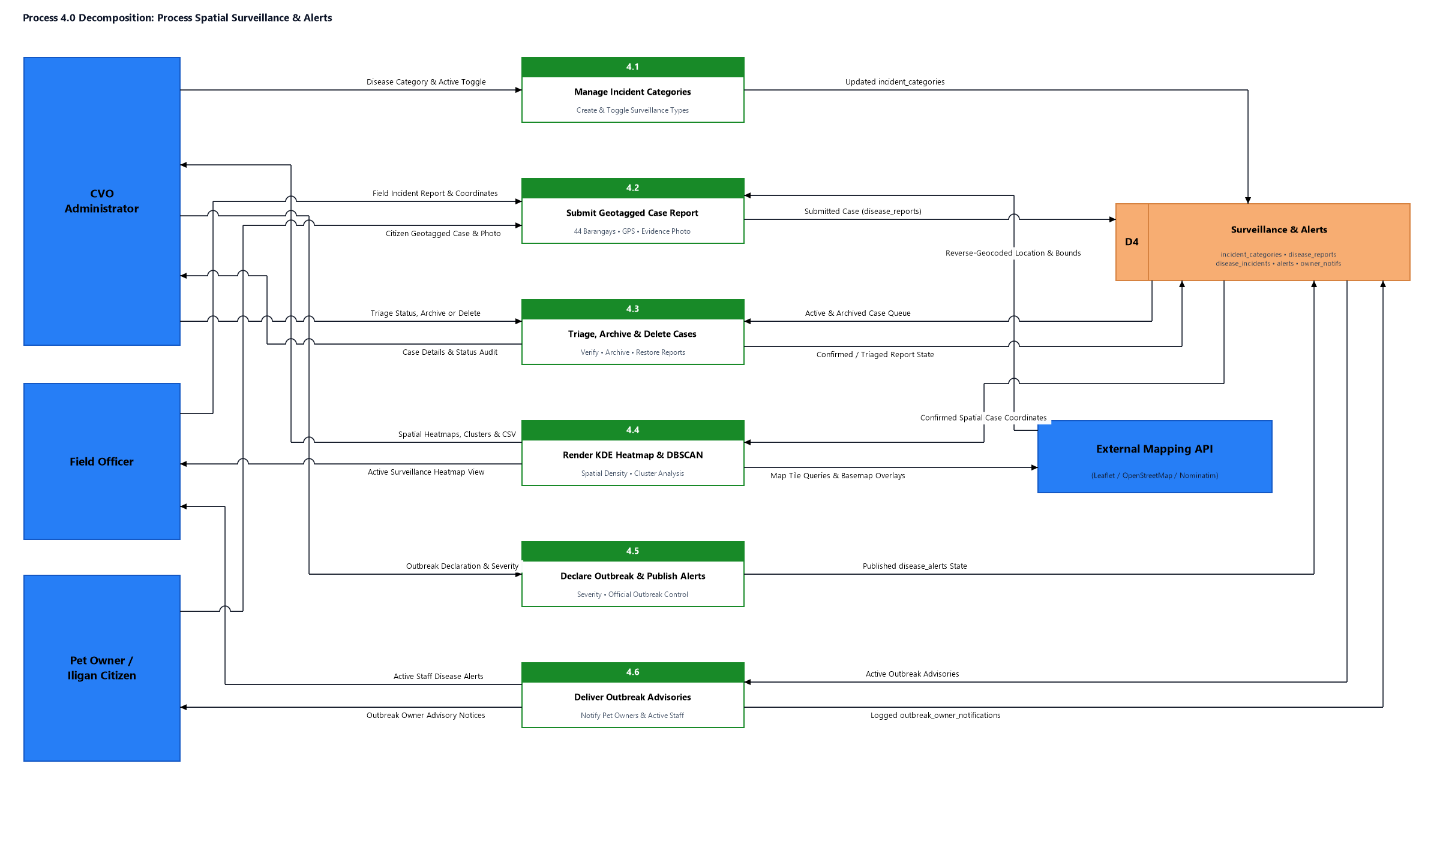
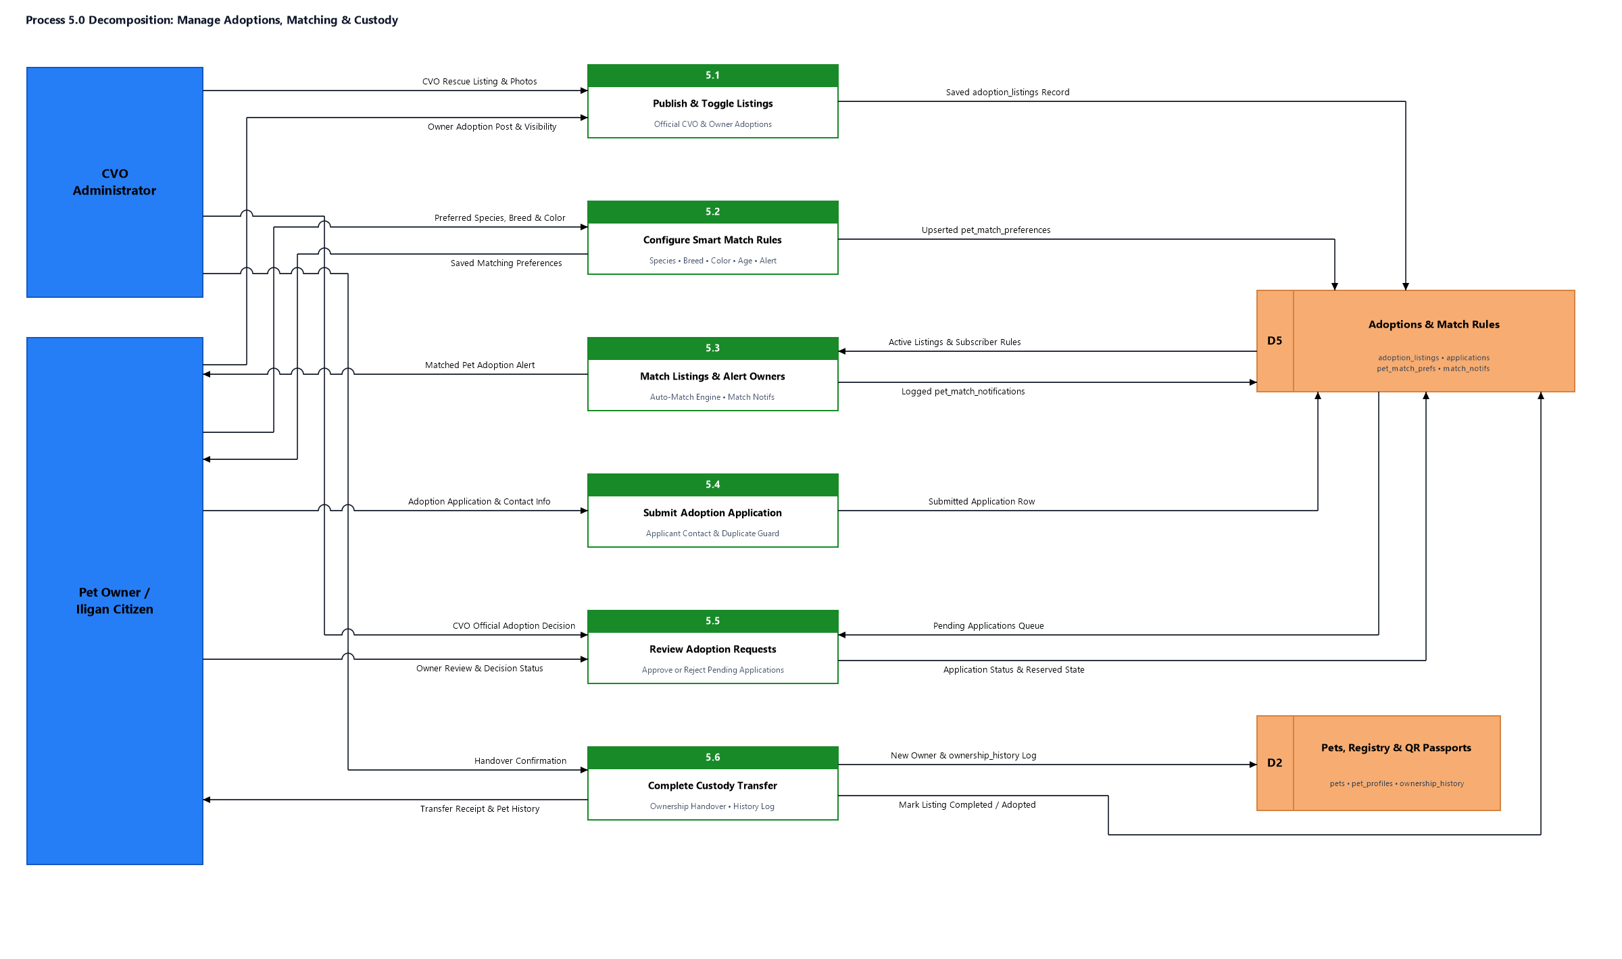
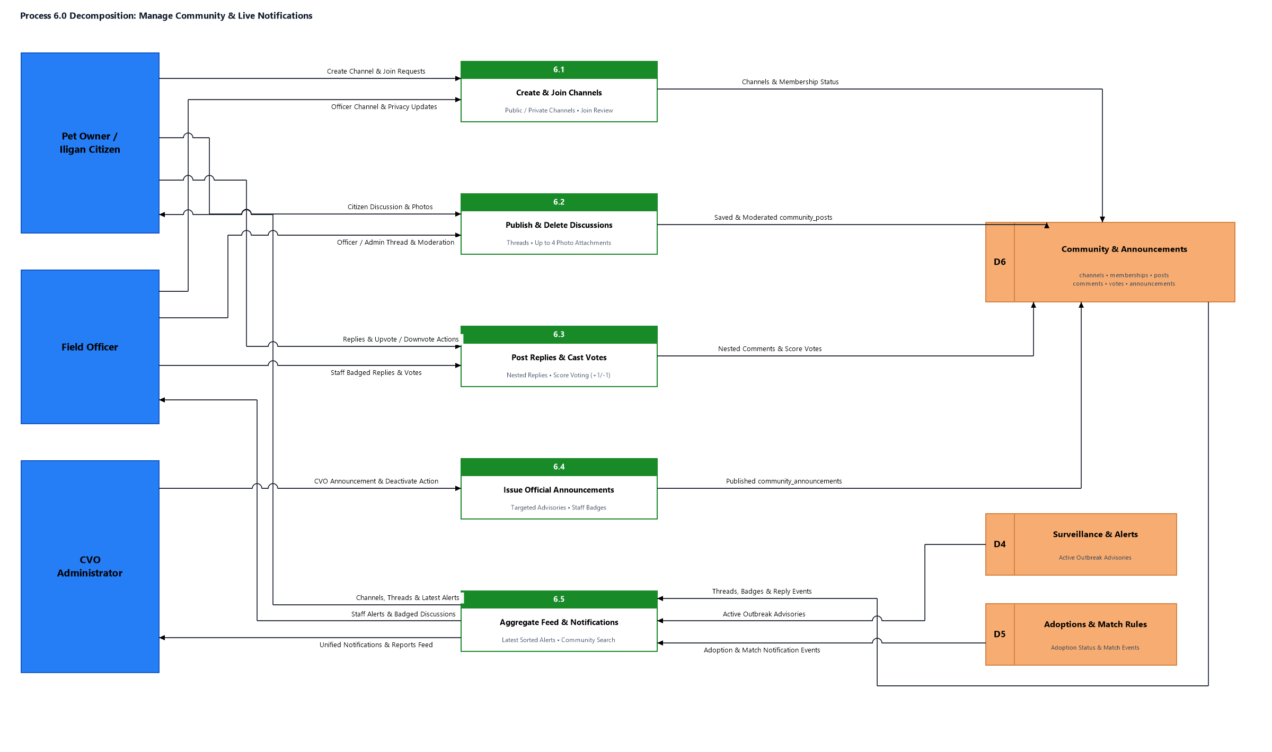
Figure 3.7 Decomposition
The decomposition diagram illustrates the detailed processes for managing user authentication and verification, pet registration and QR passports, clinical medical records and owner uploads, spatial disease surveillance and outbreak alerts, pet adoptions and custody transfers, and community interactions with live notifications within the CityVetHub Ecosystem.
The Manage Auth, Profiles & Verification process (1.0) allows Pet Owners and CVO Administrators to handle account access, profile information, and identity validation. Pet Owners can register accounts with email verification, update profile details and Iligan City barangay assignments, and submit government ID documents for approval, while CVO Administrators manage accepted ID categories, review and approve owner verification requests, and administer Field Officer and administrator role accounts stored in the Users & Verification (D1) data store.
The Manage Pets, Registry & QR Passports process (2.0) enables Pet Owners and CVO Administrators to create, update, remove, and view animal registry records. Pet Owners can register new pet profiles with optional two-parent ancestry, synchronize consent-filtered public QR passport views, request official CVO verification, or delete personal pet profiles, while CVO Administrators approve verified pets, reserve sequential CVO registration tag IDs, and view verified registry records retrieved from the Users & Verification (D1) and Pet Registry & QR Passports (D2) data stores.
The Process Medical & Owner Health Uploads process (3.0) allows Pet Owners, CVO Administrators, and Field Officers to maintain clinical histories and owner-uploaded veterinary attachments. CVO Administrators and Field Officers record official vaccinations and medical treatments, whereas Pet Owners upload personal health documents, control public QR passport visibility, view combined medical and vaccine histories, or remove uploaded files using pet data from Pet Registry & QR Passports (D2) and clinical entries in Medical & Health Records (D3), while dispatching treatment alerts to Community & Notifications (D6).
The Process Spatial Surveillance & Alerts process (4.0) enables Pet Owners, CVO Administrators, and Field Officers to report, inspect, and analyze animal disease incidents with the External Mapping API. CVO Administrators manage incident categories and declare barangay-level disease outbreaks, users and Field Officers submit geotagged case reports across Iligan City's 44 barangays, staff triage, archive, or delete cases, and authorized personnel generate KDE heatmaps and DBSCAN spatial clusters over Pet Registry & QR Passports (D2) and Disease Surveillance (D4) while delivering outbreak advisories via Community & Notifications (D6).
The Manage Adoptions, Matching & Custody process (5.0) supports the full pet rehoming lifecycle from listing to ownership transfer. Pet Owners and CVO Administrators publish and toggle verified adoption listings, prospective adopters configure smart match rules so automated matching alerts owners to newly published pets, applicants submit adoption applications, and listing owners review requests and execute finalized custody transfers across Users & Verification (D1), Pet Registry & QR Passports (D2), and Adoptions & Custody (D5), pushing match and handover notifications through Community & Notifications (D6).
The Manage Community & Live Notifications process (6.0) maintains community discussions, official CVO broadcasts, and real-time activity alerts. Users create and join discussion channels, publish or delete posts, and submit replies or votes, while CVO Administrators issue citywide announcements and the notification engine aggregates cross-domain interactions from Disease Surveillance (D4), Adoptions & Custody (D5), and Community & Notifications (D6) to keep users promptly informed of relevant system activity.

Mobile Interface
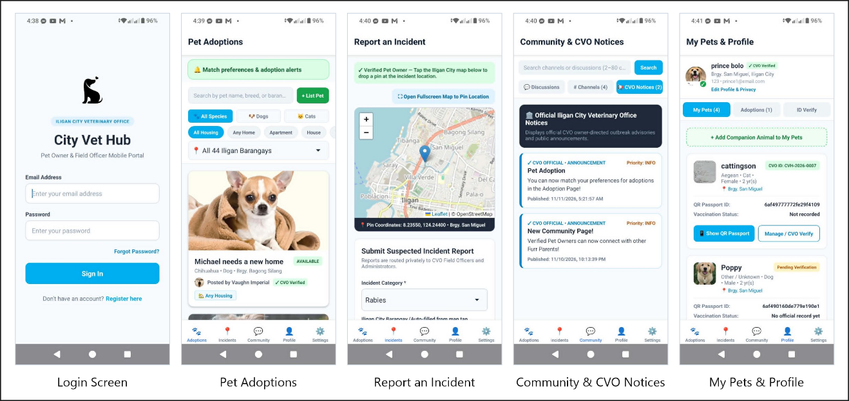Figure 3.8 Mobile Interface

The mobile interface of the developed City Vet Hub (Pet Owner & Field Officer Mobile Portal) illustrates the screens and features designed to provide pet owners and field personnel with mobile access to municipal veterinary services, community coordination, and spatial reporting across Iligan City. The interface comprises five main screens, namely the Login Screen, Pet Adoptions, Report an Incident, Community & CVO Notices, and My Pets & Profile. The Login Screen serves as the entry point to the mobile portal, displaying the Iligan City Veterinary Office badge, system branding, email and password authentication fields, password recovery access, and new account registration before directing verified users into the application.

The Pet Adoptions screen serves as the central rehoming hub, displaying adoption match preferences and alerts alongside search and filtering controls by species (Dogs and Cats), housing suitability (Any Home, Apartment, and House), and all 44 Iligan City barangays. Users can create new pet listings or browse verified adoption cards that display availability status, pet attributes, housing requirements, and owner CVO verification badges. Meanwhile, the Report an Incident screen provides verified pet owners with an interactive Iligan City Leaflet/OpenStreetMap view where they can drop a location pin to capture exact GPS coordinates and automatically detect the corresponding barangay, then submit suspected disease incident reports—such as rabies cases—directly to CVO Field Officers and Administrators.

The Community & CVO Notices screen facilitates owner-to-owner engagement and municipal communication by allowing users to search threads, switch between Discussions, Channels, and CVO Notices tabs, and read prioritized official Iligan City Veterinary Office outbreak advisories and public announcements with publication timestamps. The My Pets & Profile screen presents the user's verified account details, barangay assignment, and privacy editing options together with sub-tabs for My Pets, Adoptions, and ID Verification. From this view, owners can register companion animals, track CVO verification and vaccination statuses, inspect assigned CVO IDs, and open each pet's digital QR Passport or manage verification requests.

The application also features a persistent bottom navigation bar that enables seamless switching across the Adoptions, Incidents, Community, Profile, and Settings sections, along with in-app adoption match alerts and CVO notices to keep users informed. By integrating verified pet registration, QR traceability, geotagged disease reporting, adoption matching, and community advisories into one mobile workflow, the City Vet Hub mobile application equips Iligan City citizens and veterinary personnel to coordinate responsible pet ownership and public health surveillance through a centralized, user-friendly platform.
Hardware Requirements
The following is a list of hardware needed for the development, hosting, and deployment of the system.

Development Hardware
- Central Processing Unit (CPU): AMD Ryzen 5 (5000 series or higher) or Intel Core i5/i7 (11th Gen or higher).
- Random Access Memory (RAM): 8GB minimum (16GB recommended).
- Storage: 512GB Solid State Drive (SSD)
- Testing Smartphone Devices: Android and iOS mobile devices (running Android 10+ or iOS 15+)
- Network Infrastructure: Broadband internet connection with a minimum speed of 25 Mbps

Deployment Hardware
- Cloud Production Server: Appwrite Server
- Cloud Database Server: Cloud-based server set up to act as a database server that supports spatial indexes.
- Client End-User Devices: Advanced cellphones equipped with a camera to perform citizens and field scans, as well as desktop PCs or laptops for CVO personnel accessing the management dashboard.
Software Requirements
The following is the list of specialized applications, frameworks, programming toolkits, and environments used in both the development and deployment of both front end interactions and back end logic.

Development Software
- Operating System: Windows 10/11 or macOS
- Integrated Development Environment: Visual Studio Code
- Back-End Framework: Appwrite Cloud
- Front End Frameworks: HTML,CSS, and Javascript
- Database Management System: Appwrite(PostgreSQL) server
- Map Service Integrations: Mapping APIs(Leaflet)

Deployment Software
- Server Operating System: Windows-based distribution
- Web Server & WSGI Gateway: Appwrite Cloud
- Database Engine: Appwrite(PostgreSQL) database.
- Client Software Environments: Typical mobile app client environment for civilians/employees plus popular web browser environments (Google Chrome, Mozilla Firefox, Microsoft Edge or Apple Safari).

Respondents of the Study
The respondent group for testing the functionality, usability, and feasibility of the City Vet Hub consists of three different respondents in Iligan City. In total, 50 respondents will be sampled using purposive sampling, ensuring that all aspects of the system will be tested by those who have the necessary privileges to use it. The breakdown of the evaluators in the study is shown in Table 3.1:

Table 3.1

Respondents of the Study
Respondents | Frequency | Percentage
City Veterinary Office (CVO) Administrators / Staff | 4 | 12%
Field Personnel / Field Veterinarians | 6 | 28%
Iligan City Citizens and Pet Owners | 40 | 60%
Total | 50 | 100%

Testing Procedures
This process involves both the evaluation of the prototypes and usability tests to verify the reliability, security, and effectiveness of the prototype software within all the outlined clients' scopes. This procedure will be carried out by means of the following five-stage pipeline:
- Preparation: Researchers will set up the Appwrite.io backend services, initiate the operational release of the HTML, CSS, and JavaScript-based Web Admin Panel, and compile the mobile applications using Expo. In addition to this, mock data (pet registration forms, barangay infection reports, and adoption listings) will be created in the Appwrite database.
- Orientation: Participants will gather at the orientation session to familiarize themselves with the City Vet Hub scope, primary aims, and structure. Users will be informed in advance that during the process, their technical competence is not going to be assessed.
- Task Execution: Each participant performs tasks independently according to his/her role type:
  - Citizens / Pet Owners: Registering and scanning pets, posting and commenting on the community hub, uploading pets for peer-to-peer adoption, and reporting possible disease cases (without viewing spatial heatmaps or alerts).
  - Field Officers: Performing all citizen tasks, plus viewing the restricted spatial heatmaps, receiving outbreak alerts, looking up municipal pet records, and uploading rescued pets to the adoption feed.
  - CVO Administrators: Executing all field officer functions, plus utilizing high-level access to moderate the community hub, ban users, manage database entries, and administer official adoption listings via the web panel.

- Observation and Recording: All sessions of the study are closely monitored by researchers to log the responses of the system in terms of its responsiveness, scanning speed, and any exception.
- Feedback Collection: After performing all assigned activities, all 50 participants fill out the usability questionnaire.

Evaluation Tool
In this study, the main assessment technique will be based on the System Usability Scale (SUS). The questionnaire uses the 5-point Likert scale, where rating 5 means Strongly Agree, rating 4 stands for Agree, rating 3 stands for Neutral, rating 2 indicates Disagree and rating 1 means Strongly Disagree. This questionnaire consists of questions designed to assess four major criteria of the system's performance: Functionality, Usability, Efficiency, and User Satisfaction. In order to derive qualitative implications from quantitative data collected from 50 participants, the average values will be assessed according to the following scale shown in Table 3.2:

Table 3.2
System Usability Scale (SUS) Score Interpretation Table
Rating | Scoring Scale | Qualitative Interpretation
5 | 4.20 – 5.00 | Very Acceptable
4 | 3.40 – 4.19 | Acceptable
3 | 2.60 – 3.39 | Fairly Acceptable
2 | 1.80 – 2.59 | Slightly Acceptable
1 | 1.00 – 1.79 | Not Acceptable

Ethical Considerations
The development process, data collection and prototype testing is carried out with strict adherence to the ethical design framework.
- Data Privacy and Legal Compliance: According to the provisions of the Data Privacy Act of 2012 (Republic Act No. 10173), sensitive personal information acquired from the mobile registration process of citizens in terms of addresses, telephone numbers and geolocation stamps will be fully encrypted. Access shall be limited to encrypted database forms that are protected by password encryption solely for this particular research project.
- Informed Consent: Participants who are involved in building the mobile apps and using the web-based administrative program will be provided with informed consent. These include aspects on how the data gathered will be used, limitations of the software and how participants may freely terminate their involvement in this research.
- Algorithmic Transparency and Explainability: The program will remain transparent throughout its development and deployment. If any spatial areas that indicate risk of any particular disease or state during the adoption pipeline will come up, then confidence measures, map labels and parameter values will be provided by the program so that the CVO personnel will have reasons behind the output.
- Prevention of Misuse and Operational Boundaries: The City Vet Hub will be designed to be a support for automatic decision making. The purpose of the study is to increase the efficiency of the city veterinary office, and there are clear disclaimers in the system’s user interface that dictate the fact that the results generated by the system are purely computational and will not be doing medical diagnoses.

CHAPTER 4

RESULTS AND DISCUSSION
This chapter presents the developed CityVetHub web application and mobile application prototypes for the Iligan City Veterinary Office. It walks through the implemented interfaces and operational workflows across platforms, beginning with the CityVetHub Web Application for Pet Owners and CVO Administrators (Figures 4.1 to 4.20), followed by the CityVetHub Mobile Application for Pet Owners and Field Officers (Figures 4.21 to 4.32), illustrating how pet registration, CVO Verified digital QR traceability, clinical recordkeeping, adoptions, community engagement, and spatial disease surveillance operate within strict role-based boundaries.
Description of the Prototype
Web Application
Pet Owner Interface (Web Application)
Login Page (Web Application)
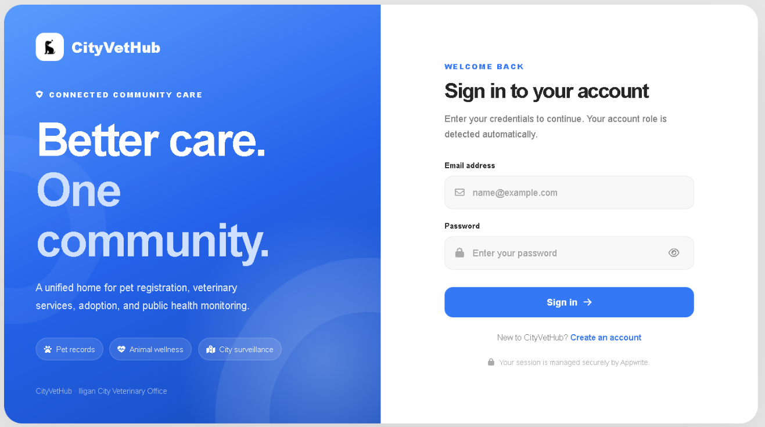
Figure 4.1 Login Page
The Login Page serves as the unified authentication gateway to the CityVetHub web application. Its left panel introduces the platform under the Connected Community Care branding for the Iligan City Veterinary Office, highlighting its core areas of pet records, animal wellness, and city surveillance. The right panel displays the sign-in form containing email address and password input fields with a visibility toggle icon, a Sign In button that authenticates users through Appwrite and automatically routes them based on their assigned account role, and a Create an Account link for new citizens registering on the platform.
Pet Owner Dashboard Page (Web Application)
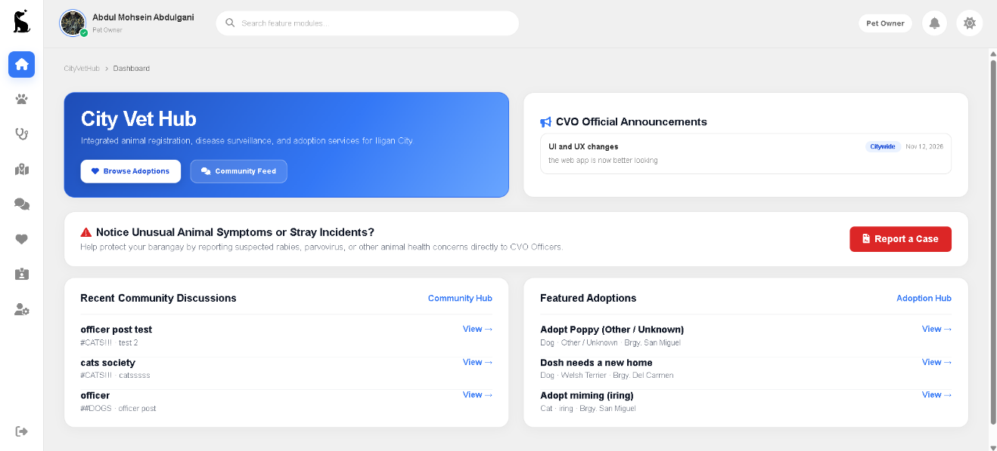
Figure 4.2 Pet Owner Dashboard Page
The Pet Owner Dashboard Page serves as the citizen home workspace after signing in. Across the top bar, the page displays the signed-in owner profile with a CVO Verified badge indicator, a global Search feature modules input, a Pet Owner role indicator, notifications, and theme settings alongside the left icon navigation rail. The main canvas presents a welcome banner with quick-access Browse Adoptions and Community Feed buttons, a CVO Official Announcements panel for citywide advisories, an alert banner with a Report a Case shortcut for suspected animal health incidents, and side-by-side summaries of Recent Community Discussions and Featured Adoptions.
My Pets Page (Web Application)
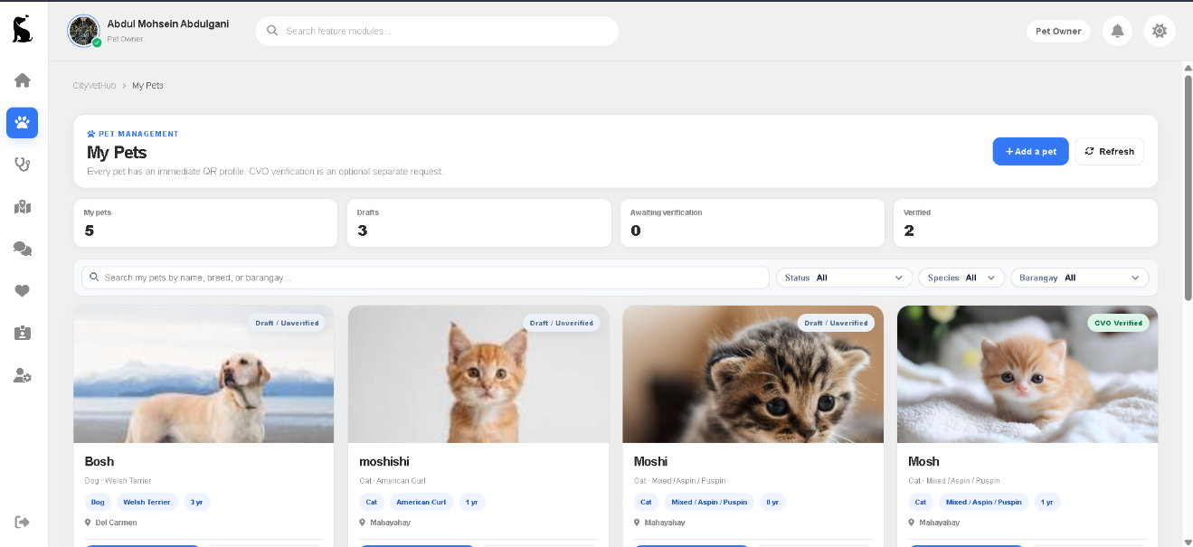
Figure 4.3 My Pets Page
The My Pets Page enables Pet Owners to manage their personal pet inventory and track official registration requests with the City Veterinary Office. The header provides Add a Pet and Refresh action buttons, followed by four summary cards displaying total pets, draft profiles, profiles awaiting verification, and CVO Verified pets. Below the summary cards, a search bar and Status, Species, and Barangay dropdown filters narrow the pet cards displayed in the grid, where each card presents the animal’s photo, verification status badge, name, species, breed, age, and barangay.
Medical & Vaccination Page (Pet Owner - Web Application)
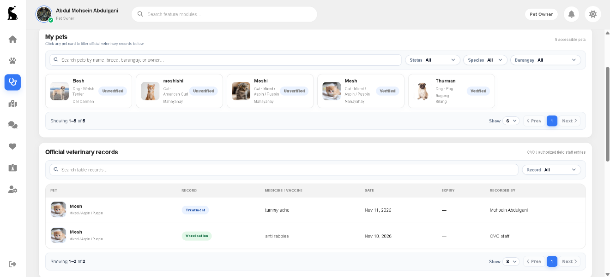
Figure 4.4 Medical & Vaccination Page (Pet Owner)
The Medical & Vaccination Page allows Pet Owners to review veterinary immunizations and treatments linked to their animals. The upper panel lists the owner’s accessible pets with search and Status, Species, and Barangay filters, letting users select any pet card to filter the clinical records below. The lower Official Veterinary Records table presents treatments and vaccinations recorded by authorized CVO personnel, showing the pet name, record type, administered medicine or vaccine, administration date, booster expiry date, and recording clinician.
Report an Incident Page (Web Application)
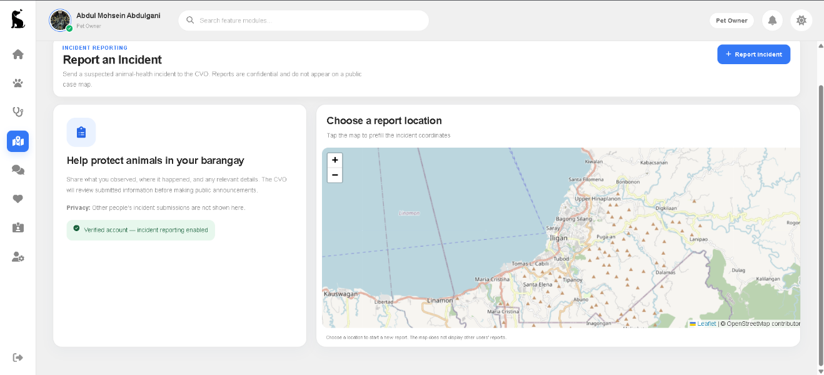
Figure 4.5 Report an Incident Page
The Report an Incident Page enables verified Pet Owners to submit geotagged animal health or stray incident reports to the City Veterinary Office while keeping public surveillance heatmaps restricted to authorized personnel. The header includes a Report Incident button and privacy assurance indicating that citizen submissions remain confidential. On the left, a guidance card outlines what details to provide and displays the owner’s verified reporting status badge; on the right, an interactive Leaflet map centered on Iligan City lets users tap a location to prefill exact geographic coordinates before completing the report form.
Community Page (Pet Owner - Web Application)
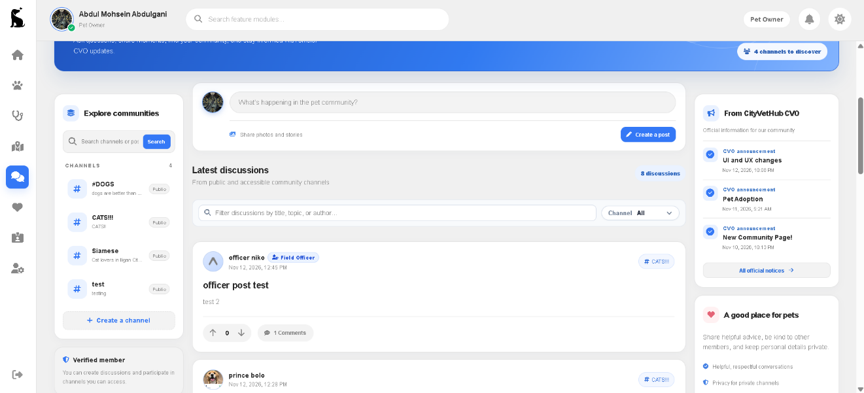
Figure 4.6 Community Page (Pet Owner)
The Community Page provides an interactive discussion forum where Iligan City pet owners connect and follow official City Veterinary Office updates. Its top banner highlights available channels, while the left sidebar lists public channels with search filtering, a Create a Channel button, and member status details. The center column contains a discussion post composer, a filterable feed of recent discussions tagged by channel with upvote, downvote, and reply controls, and a right sidebar featuring official CVO announcements and community guidelines.
Adoptions Page (Pet Owner - Web Application)
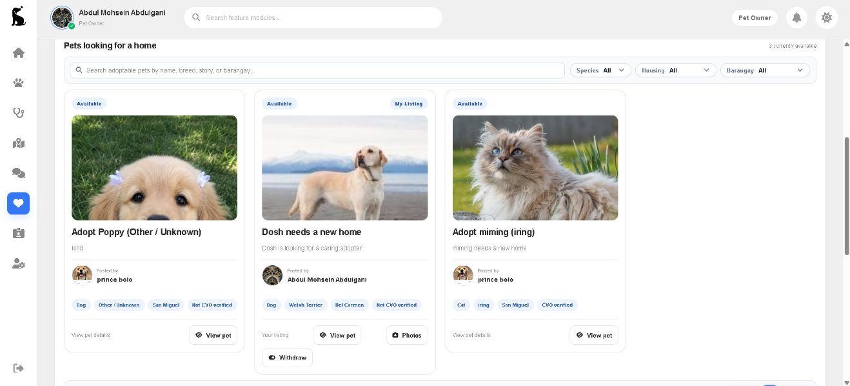
Figure 4.7 Adoptions Page (Pet Owner)
The Adoptions Page displays pets currently available for adoption across Iligan City and supports peer-to-peer adoption workflows. A search field and Species, Housing, and Barangay filter pills help citizens locate suitable animals among active listings. Each card shows the availability status badge, pet photo, listing title, short description, posting owner attribution, attribute tags including CVO Verified status, and View Pet controls—alongside Photos and Withdraw actions on listings created by the signed-in owner.
Ownership & Traceability Page (Pet Owner - Web Application)
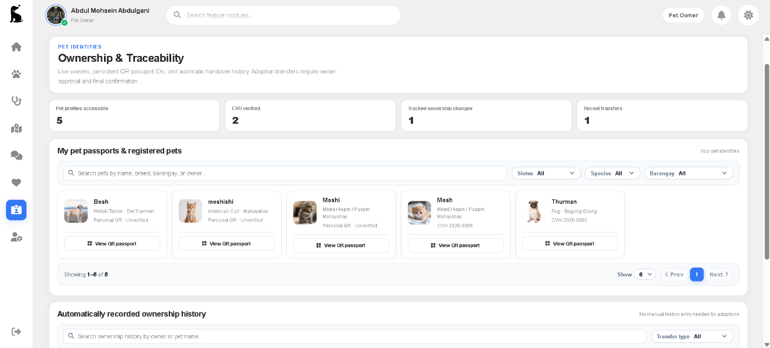
Figure 4.8 Ownership & Traceability Page (Pet Owner)
The Ownership & Traceability Page provides Pet Owners with digital QR passport access and a transparent audit log of custody handovers. Four summary cards report accessible pet profiles, CVO Verified pets, tracked ownership changes, and recent transfers. Under My Pet Passports & Registered Pets, owners can filter their animals and open each pet’s public View QR Passport page showing either a personal unverified QR tag or an assigned official ID such as CVH-2026-0005, while the lower section lists automatically recorded ownership transfer history filterable by transfer type.
My Profile Page (Pet Owner - Web Application)
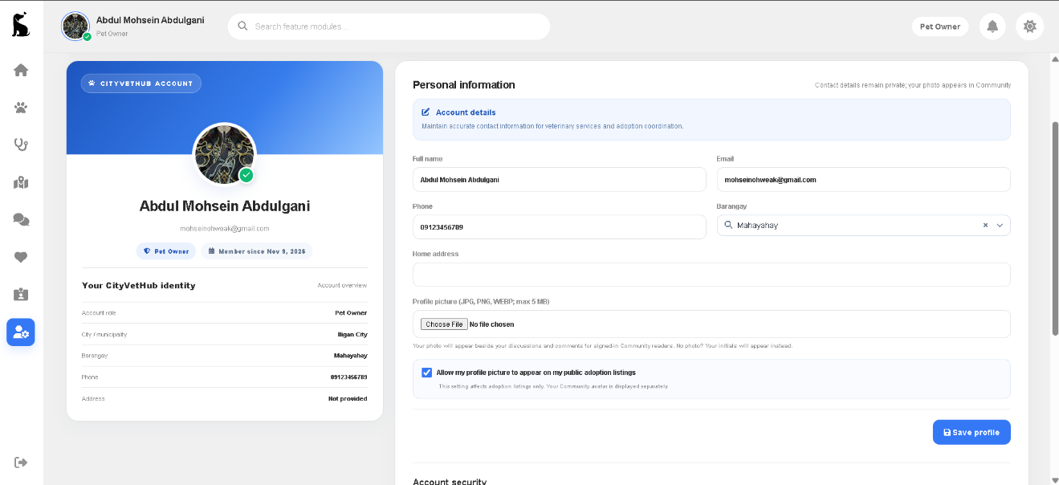
Figure 4.9 My Profile Page (Pet Owner)
The My Profile Page enables Pet Owners to maintain their account identity, barangay residence details, and privacy preferences. The left identity card displays the user’s verified avatar, full name, email address, Pet Owner role badge, membership start date, and an identity summary. On the right, the Personal Information form provides editable fields for full name, email, phone number, searchable Iligan City barangay selection, home address, profile picture upload, an optional avatar-sharing consent checkbox for adoption listings, and a Save Profile button above Account Security settings.
Administrator Interface (Web Application)
Administrator Dashboard Page (Web Application)
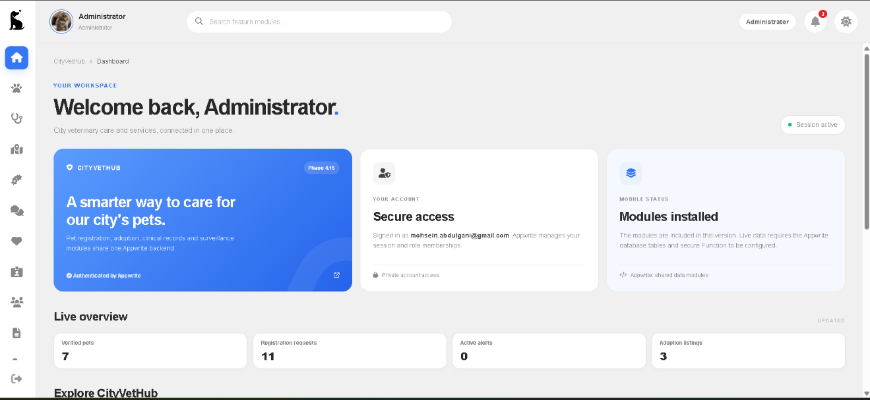
Figure 4.10 Administrator Dashboard Page
The Administrator Dashboard Page serves as the centralized operational overview for City Veterinary Office administrators upon sign-in. Alongside the top search bar, role pill, notifications, and full administrative navigation rail on the left, the workspace presents a personalized greeting, active session indicator, an Appwrite-authenticated platform overview card, account verification details, and backend module status. Beneath these cards, the Live Overview section summarizes citywide figures for verified pets, registration requests, active alerts, and adoption listings above quick module shortcuts.
Pet Verification Page (Web Application)
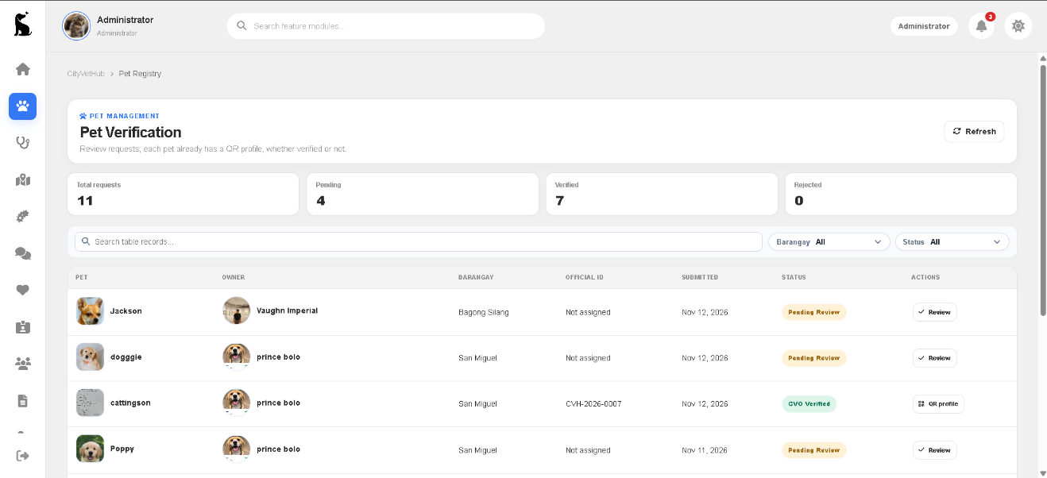
Figure 4.11 Pet Verification Page
The Pet Verification Page allows CVO Administrators to evaluate citizen-submitted pet registration applications and issue official registry tags. Four summary cards present totals for submitted requests, pending applications, verified pets, and rejected entries. Using the search bar alongside Barangay and Status filters, administrators inspect the tabular queue displaying each pet’s photo and name, owner, barangay, assigned official ID, submission date, current review badge, and row actions to Review pending submissions or view the generated QR profile.
Medical & Vaccination Page (Administrator - Web Application)
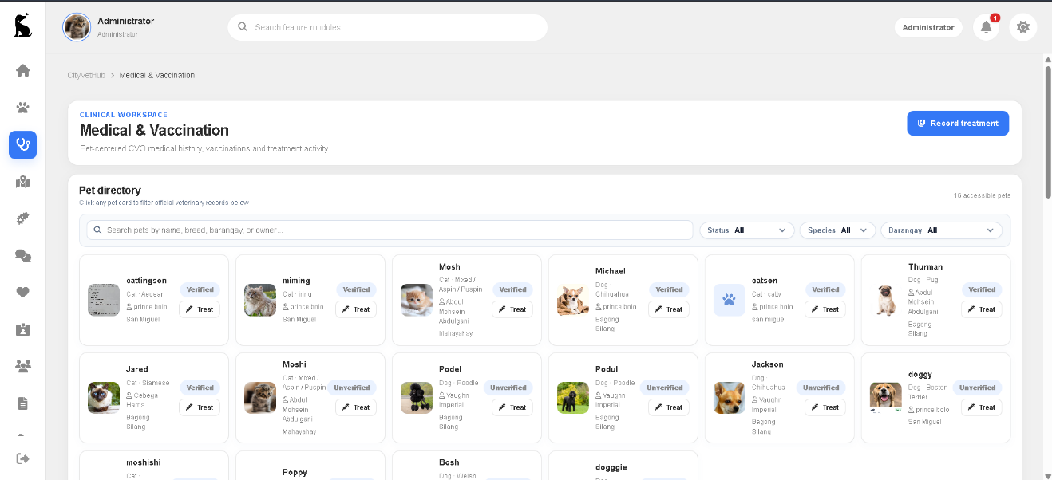
Figure 4.12 Medical & Vaccination Page (Administrator)
The Medical & Vaccination Page provides CVO Administrators with a clinical workspace to record and inspect official immunizations and medical treatments across registered animals. From the top header, staff can open the Record Treatment workflow, while the Pet Directory below displays all accessible pets with search and Status, Species, and Barangay filters. Each pet card highlights the animal’s photo, breed, owner, barangay, verification badge, and a direct Treat action button alongside click-to-filter integration with the veterinary records table.
Incident Surveillance Page (Web Application)
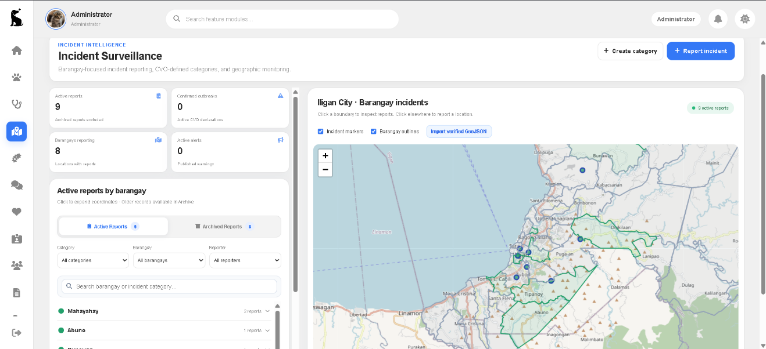
Figure 4.13 Incident Surveillance Page
The Incident Surveillance Page equips CVO Administrators with geographic monitoring tools and triage workflows for reported animal disease and stray incidents across Iligan City. Top action buttons permit creating incident categories and logging staff reports, while four KPI cards track active reports, confirmed outbreaks, reporting barangays, and published alerts. The left panel switches between active and archived reports with Category, Barangay, and Reporter filters, paired with an interactive Leaflet map displaying barangay polygon outlines, incident location markers, and verified GeoJSON import controls.
Outbreak Alerts Page (Web Application)
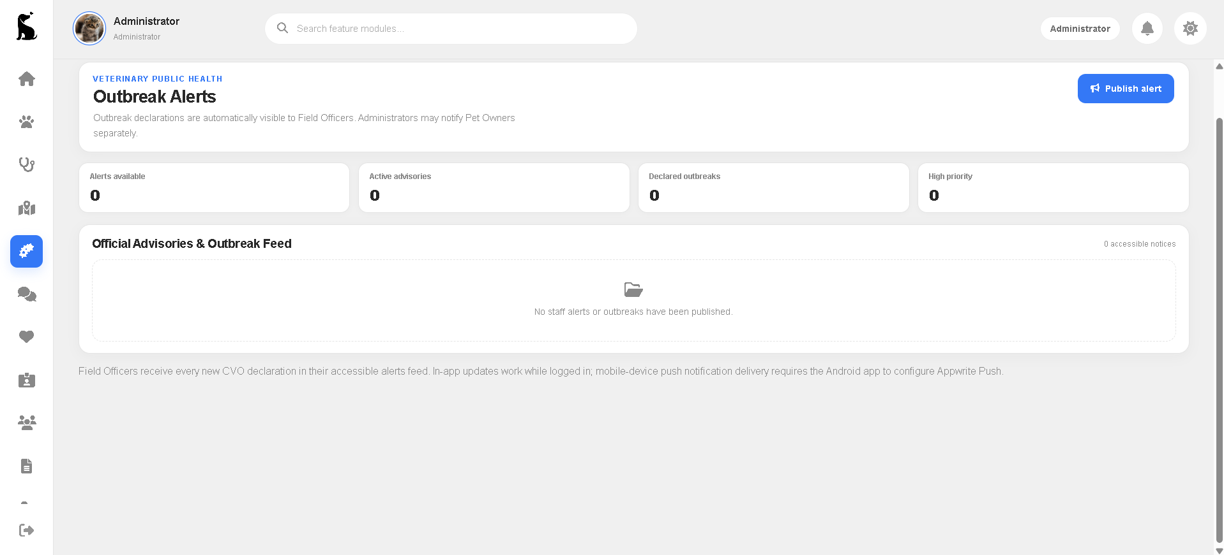
Figure 4.14 Outbreak Alerts Page
The Outbreak Alerts Page enables CVO Administrators to issue and monitor official veterinary public health advisories and barangay outbreak declarations. A Publish Alert button initiates new notices with targeted severity and optional Pet Owner notification, while four summary cards track total accessible alerts, active advisories, declared outbreaks, and high-priority notices. The Official Advisories & Outbreak Feed lists published warnings distributed in real time to Field Officers and citizen feeds.
Community Page (Administrator - Web Application)
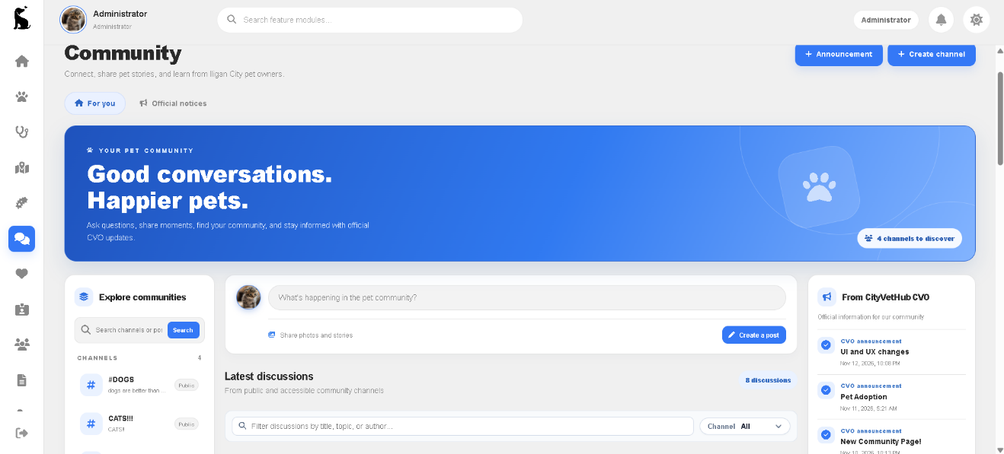
Figure 4.15 Community Page (Administrator)
The Community Page in the Administrator view extends the public forum with official broadcast and moderation capabilities for the City Veterinary Office. In addition to participating in public channels and filtering discussions, administrators have dedicated header actions to publish official Announcement notices and create channels, plus tabs switching between For You discussions and Official Notices. The right sidebar surfaces official CVO Announcements alongside discussion channels and community moderation controls.
Adoptions Page (Administrator - Web Application)
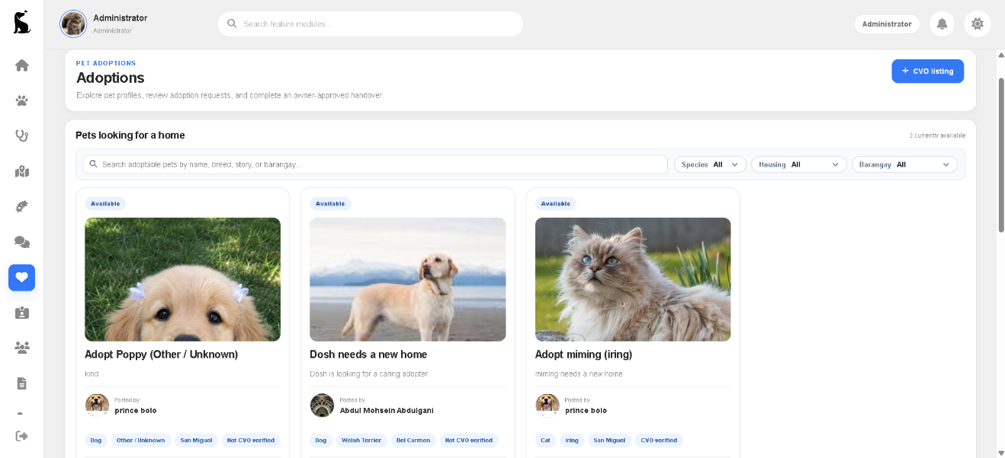
Figure 4.16 Adoptions Page (Administrator)
The Adoptions Page provides CVO Administrators with oversight of all active pet adoption listings and official shelter or rescue postings. Featuring a dedicated CVO Listing creation button in the header, administrators can publish City Veterinary Office adoption listings directly alongside citizen-posted pets. Below the header, search and Species, Housing, and Barangay filters organize available animal cards displaying verification status, owner attribution, and review controls to manage adoption requests and owner-approved handovers.
Ownership & Traceability Page (Administrator - Web Application)
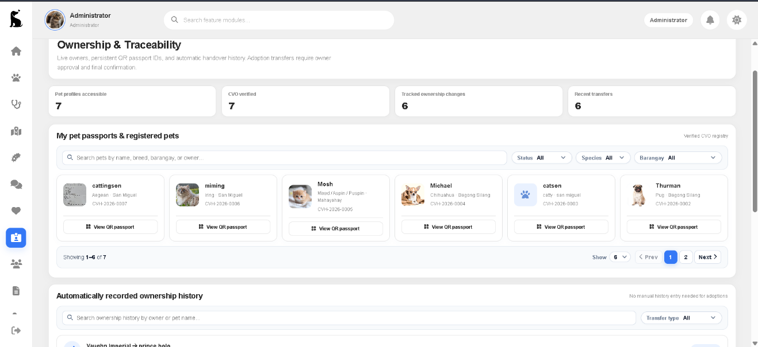
Figure 4.17 Ownership & Traceability Page (Administrator)
The Ownership & Traceability Page enables CVO Administrators to inspect citywide QR passport records and verify custody transfers across the registry. Summary cards quantify accessible pet profiles, CVO Verified records, tracked ownership changes, and recent transfers. Beneath searchable Status, Species, and Barangay filters, paginated passport cards display each animal’s assigned official CVH identifier and provide quick View QR Passport access, followed by an Automatically Recorded Ownership History ledger filterable by transfer type.
Account Management Page (Web Application)
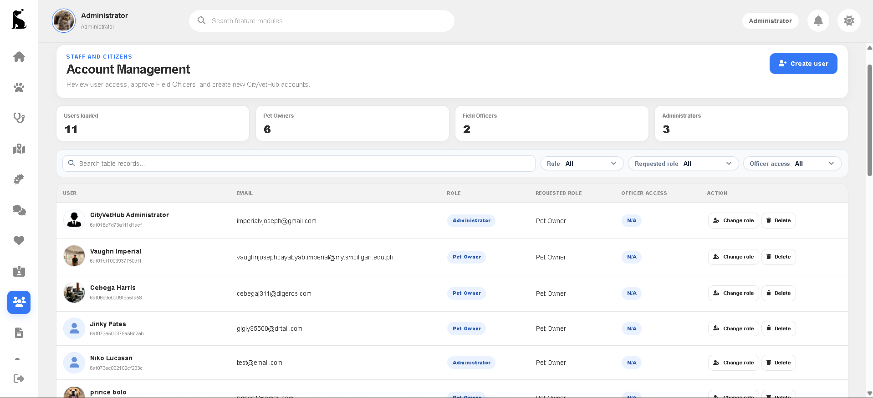
Figure 4.18 Account Management Page
The Account Management Page provides CVO Administrators with centralized user governance, Field Officer access approval, and account provisioning controls. A Create User button supports direct account creation, while four summary cards report total loaded users broken down into Pet Owners, Field Officers, and Administrators. Search and Role, Requested Role, and Officer Access filters refine the user table, where administrators can inspect email addresses, current and requested roles, and execute Change Role or Delete actions.
Administrative Reports Page (Web Application)
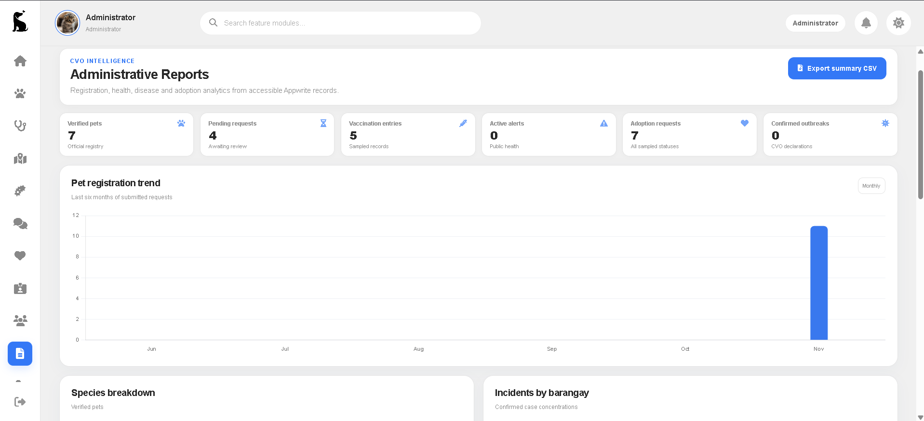
Figure 4.19 Administrative Reports Page
The Administrative Reports Page aggregates operational data across registration, veterinary health, disease surveillance, and adoptions into visual CVO intelligence summaries. Administrators can download structured records using the Export Summary CSV button while monitoring six KPI cards covering verified pets, pending requests, vaccination entries, active alerts, adoption requests, and confirmed outbreaks. Below the metrics, an interactive Chart.js Pet Registration Trend bar graph tracks six-month submission volume alongside Species Breakdown and Incidents by Barangay analytics panels.
My Profile Page (Administrator - Web Application)
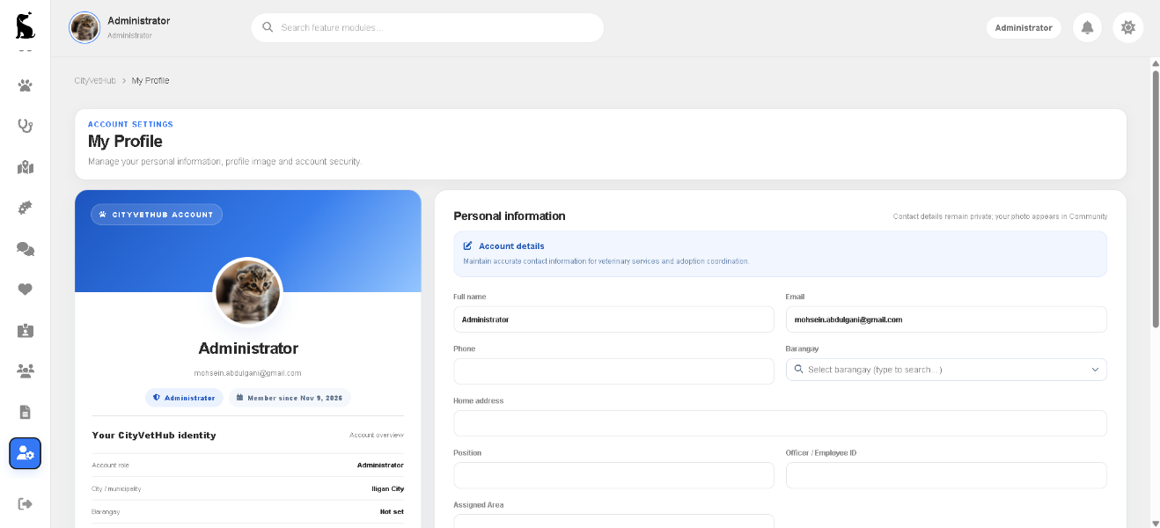
Figure 4.20 My Profile Page (Administrator)
The My Profile Page enables CVO Administrators to manage both their personal contact records and official municipal staff metadata. The left identity panel presents the administrator’s profile image, account name, email address, Administrator badge, membership date, and municipal assignment summary. On the right, the Personal Information form displays editable account fields—including full name, email, phone, searchable barangay, and home address—alongside staff-specific fields for Position, Officer or Employee ID, and Assigned Area.
Mobile Application
Pet Owner Interface (Mobile Application)
Login Screen (Mobile Application)
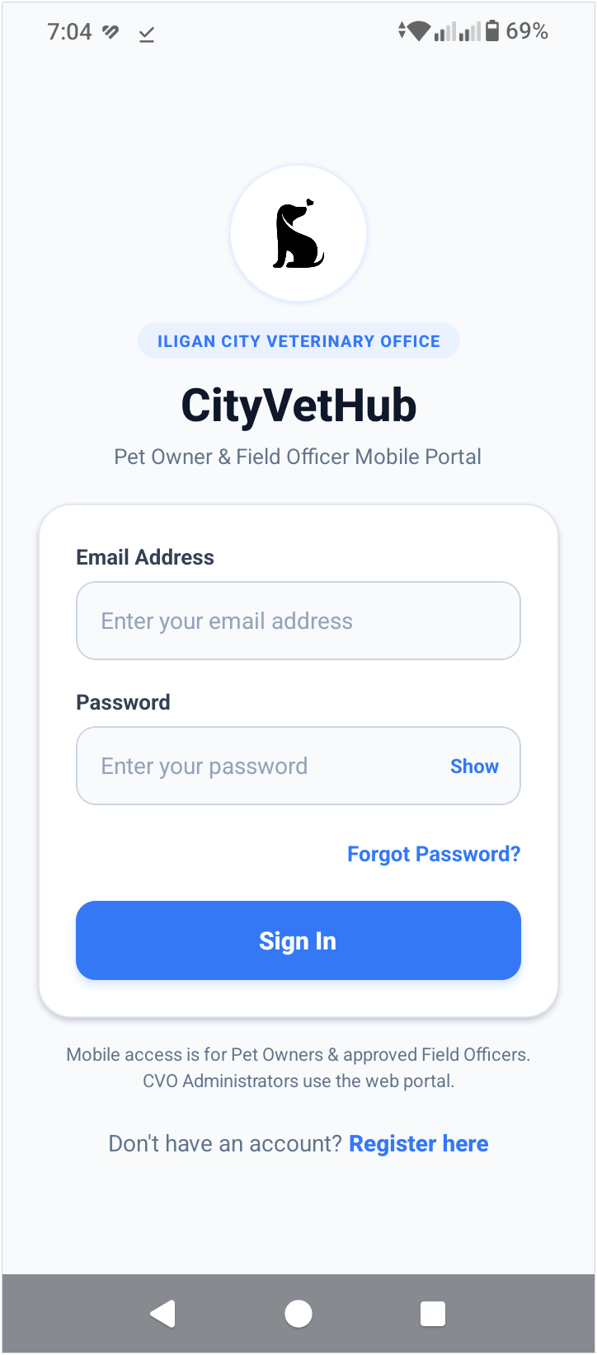
Figure 4.21 Login Screen (Mobile Application)
The Login Screen serves as the mobile authentication gateway to the CityVetHub ecosystem for the Iligan City Veterinary Office. Beneath the circular dog emblem, the ILIGAN CITY VETERINARY OFFICE header badge, and the Pet Owner & Field Officer Mobile Portal subtitle, the centered sign-in card presents Email Address and Password input fields with a Show visibility toggle, a Forgot Password? recovery link, and a Sign In button backed by Appwrite session authentication. Below the card, an access-scope notice clarifies that mobile access is restricted exclusively to Pet Owners and approved Field Officers while directing CVO Administrators to the web portal, followed by a Register here link that routes new citizens and field personnel to account registration.
Account Registration Screen (Mobile Application)
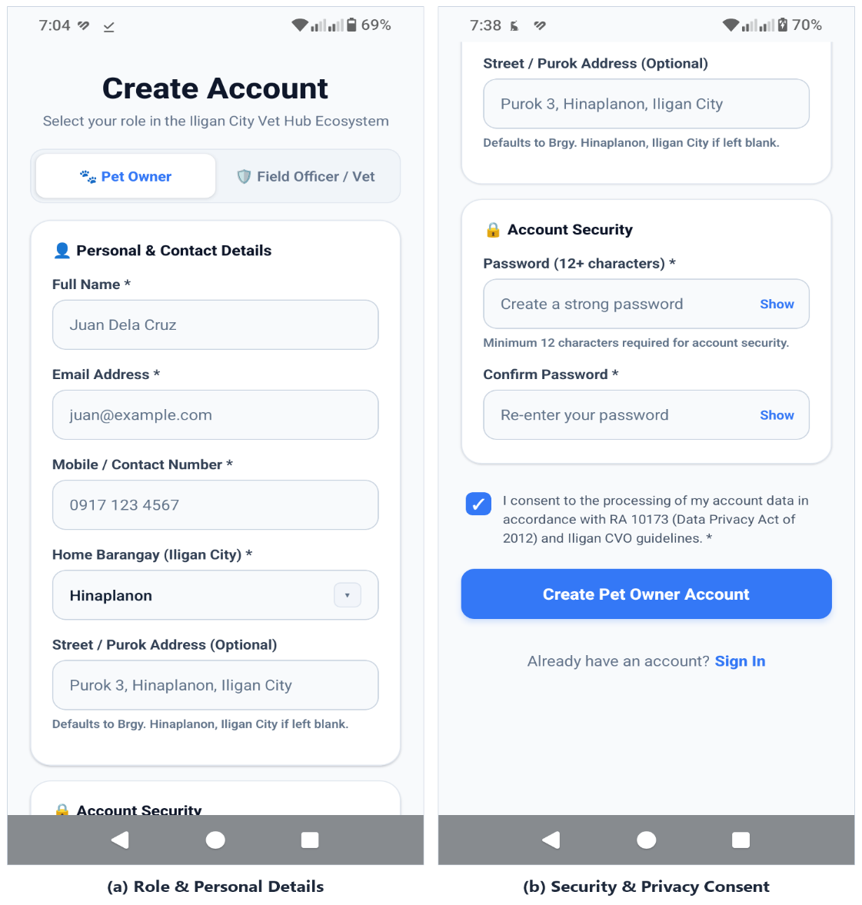
Figure 4.22 Account Registration Screen (Mobile Application)
The Account Registration Screen enables new citizens and veterinary staff to register within the Iligan City Vet Hub Ecosystem across two scrollable sections. Panel (a) presents the Create Account header, a two-option role switcher distinguishing between Pet Owner accounts and Field Officer / Vet accounts (which remain gated until approved by a CVO Administrator), and the Personal & Contact Details card capturing Full Name, Email Address, Mobile / Contact Number, Home Barangay across Iligan City, and an optional Street / Purok Address with automatic barangay fallback formatting. Continuing down the registration form, Panel (b) displays the Account Security card enforcing a minimum 12-character password and password confirmation with Show visibility toggles, a mandatory consent checkbox under Republic Act No. 10173 (Data Privacy Act of 2012) and Iligan CVO guidelines, the Create Pet Owner Account submission button, and a Sign In navigation link for existing users.
Pet Adoptions & Smart Match Preferences Screen (Mobile Application)
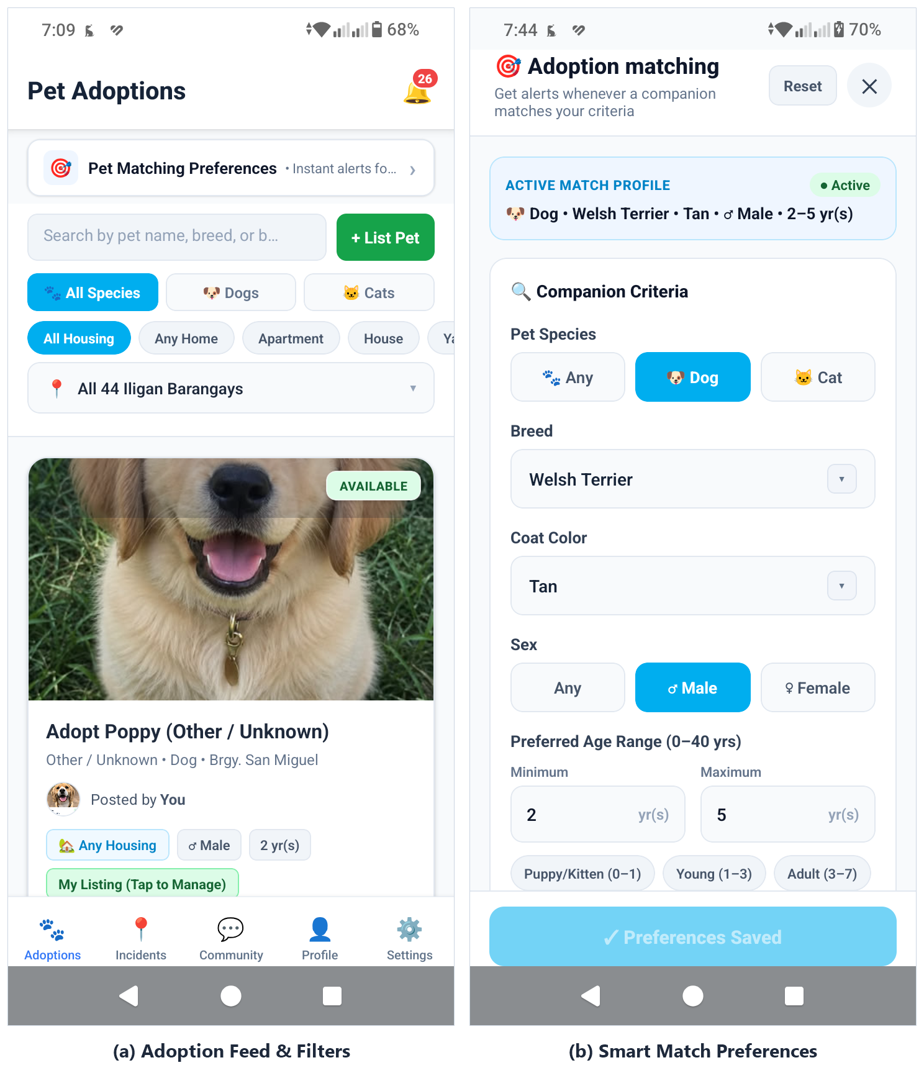
Figure 4.23 Pet Adoptions & Smart Match Preferences Screen (Mobile Application)
The Pet Adoptions & Smart Match Preferences Screen serves as the centralized mobile rehoming marketplace and personalized recommendation interface aligned with Chapter 1 Objective 3's content-based filtering workflow. In Panel (a), the five-tab Pet Owner interface (Adoptions, Incidents, Community, Profile, and Settings) displays a notification bell badge, a Pet Matching Preferences alert banner, a keyword search input paired with a + List Pet button, and multi-criteria filters for Species (All Species, Dogs, and Cats), housing suitability (All Housing, Any Home, Apartment, House, and Yard), and all 44 Iligan City barangays above listing cards showing availability badges, breed and barangay metadata, poster attribution, housing and age tags, and a My Listing (Tap to Manage) indicator for user-owned posts. Selecting the preferences banner opens the Adoption matching sheet shown in Panel (b), where prospective adopters review their Active Match Profile summary and configure personalized Companion Criteria—including species, searchable breed catalog, coat color, sex, 0–40 year age range with quick life-stage presets, automated matching toggle, and push-notification opt-in—so newly published adoption listings matching their preferences generate timely alerts.
Adoption Listing Details Screen (Mobile Application)
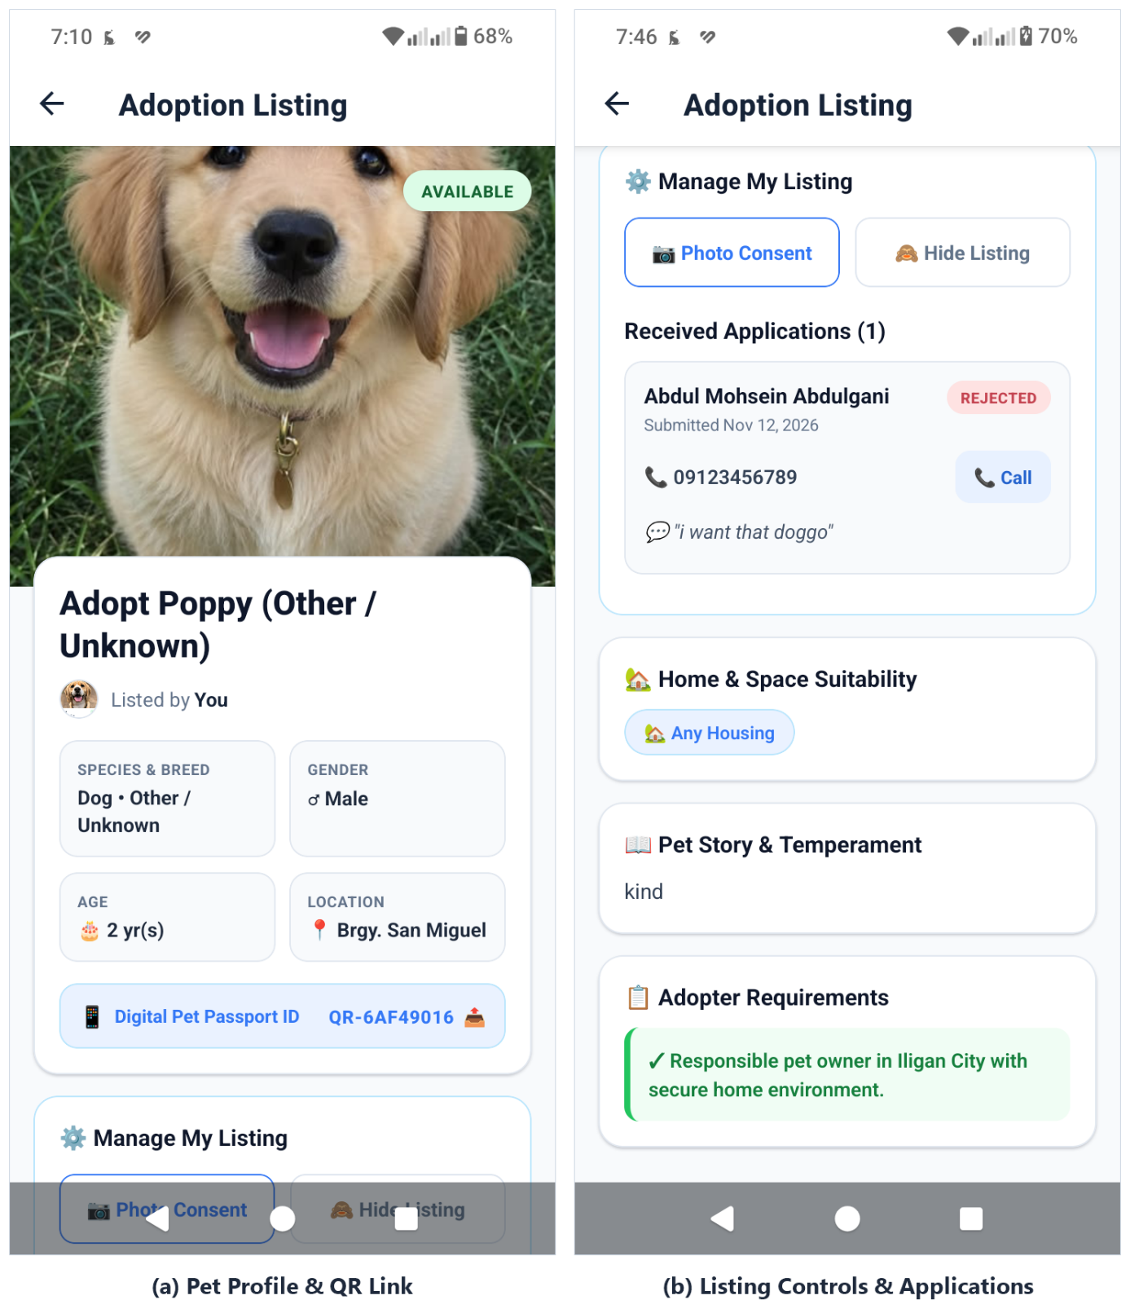
Figure 4.24 Adoption Listing Details Screen (Mobile Application)
The Adoption Listing Details Screen presents complete animal profile metadata, listing management tools, and applicant review workflows when an animal card is opened from the adoption feed. Panel (a) showcases the full-width hero pet photograph with an AVAILABLE status badge, the listing title and owner attribution, a structured attribute grid summarizing Species & Breed, Gender, Age, and Iligan City Barangay location, and a linked Digital Pet Passport ID reference row for transparent traceability. Scrolling down in Panel (b), signed-in listing owners access the Manage My Listing card with Photo Consent and Hide Listing controls alongside the Received Applications list displaying applicant names, application status badges (such as REJECTED or PENDING), submission dates, direct-dial Call phone actions, and applicant notes, followed by Home & Space Suitability, Pet Story & Temperament, and Adopter Requirements cards.
Report an Incident Screen (Mobile Application)
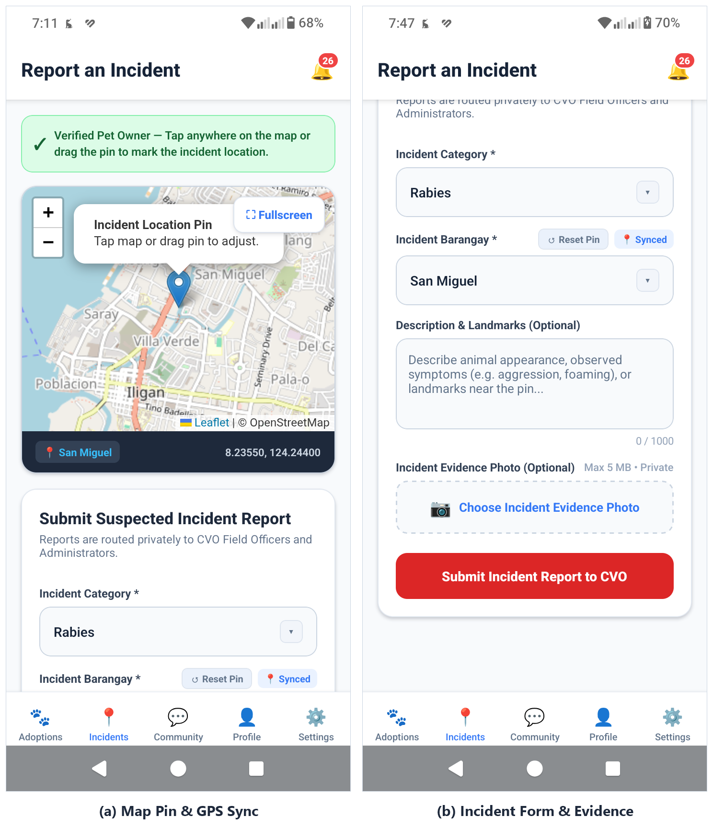
Figure 4.25 Report an Incident Screen (Mobile Application)
The Report an Incident Screen enables CVO Verified Pet Owners to submit confidential, geotagged animal health or stray incident reports to the Iligan City Veterinary Office without exposing surveillance heatmaps or citizen submissions to non-staff users. Panel (a) highlights the verified reporter status banner above an interactive Leaflet map centered on Iligan City equipped with zoom controls, a Fullscreen toggle, a draggable location pin popup, and a live footer displaying the reverse-geocoded barangay alongside exact latitude and longitude coordinates. Below the map, Panel (b) displays the Submit Suspected Incident Report card where users choose an Incident Category (such as Rabies), confirm the pin-synchronized Incident Barangay with a Reset Pin action, enter optional landmarks within a 1,000-character limit, attach an optional private evidence photograph up to 5 MB, and submit the report directly to CVO personnel.
Community & CVO Notices Screen (Mobile Application)
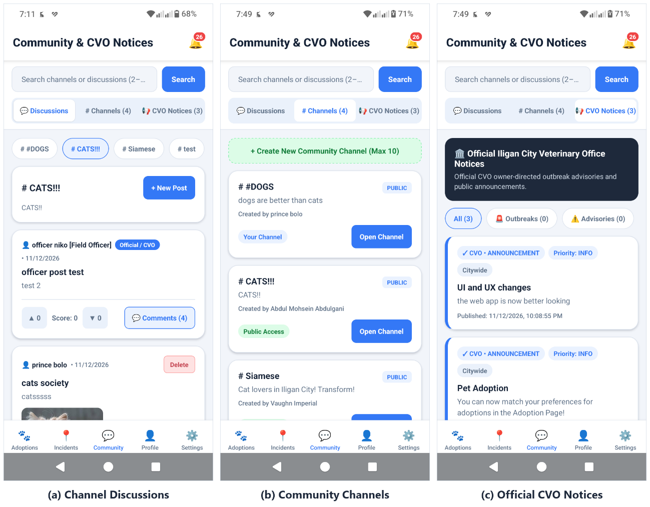
Figure 4.26 Community & CVO Notices Screen (Mobile Application)
The Community & CVO Notices Screen connects Iligan City pet owners with peer discussion channels and official municipal veterinary broadcasts through Appwrite-managed operations. Panel (a) shows the active Discussions tab beneath the keyword search bar and segmented navigation tabs, combining horizontal channel selector pills, a + New Post composer, upvote and downvote score counters, nested comment counts, owner Delete controls, and Official / CVO staff badges on posts authored by Field Officers. Panel (b) illustrates the # Channels directory view featuring a + Create New Community Channel action (up to 10 owner-managed channels) and access-labeled public or owner-created channel cards. Panel (c) displays the CVO Notices tab with an Official Iligan City Veterinary Office Notices header, Outbreaks and Advisories filters, citywide scope labels, and timestamped municipal announcements.
My Pets & Profile Screen (Mobile Application)
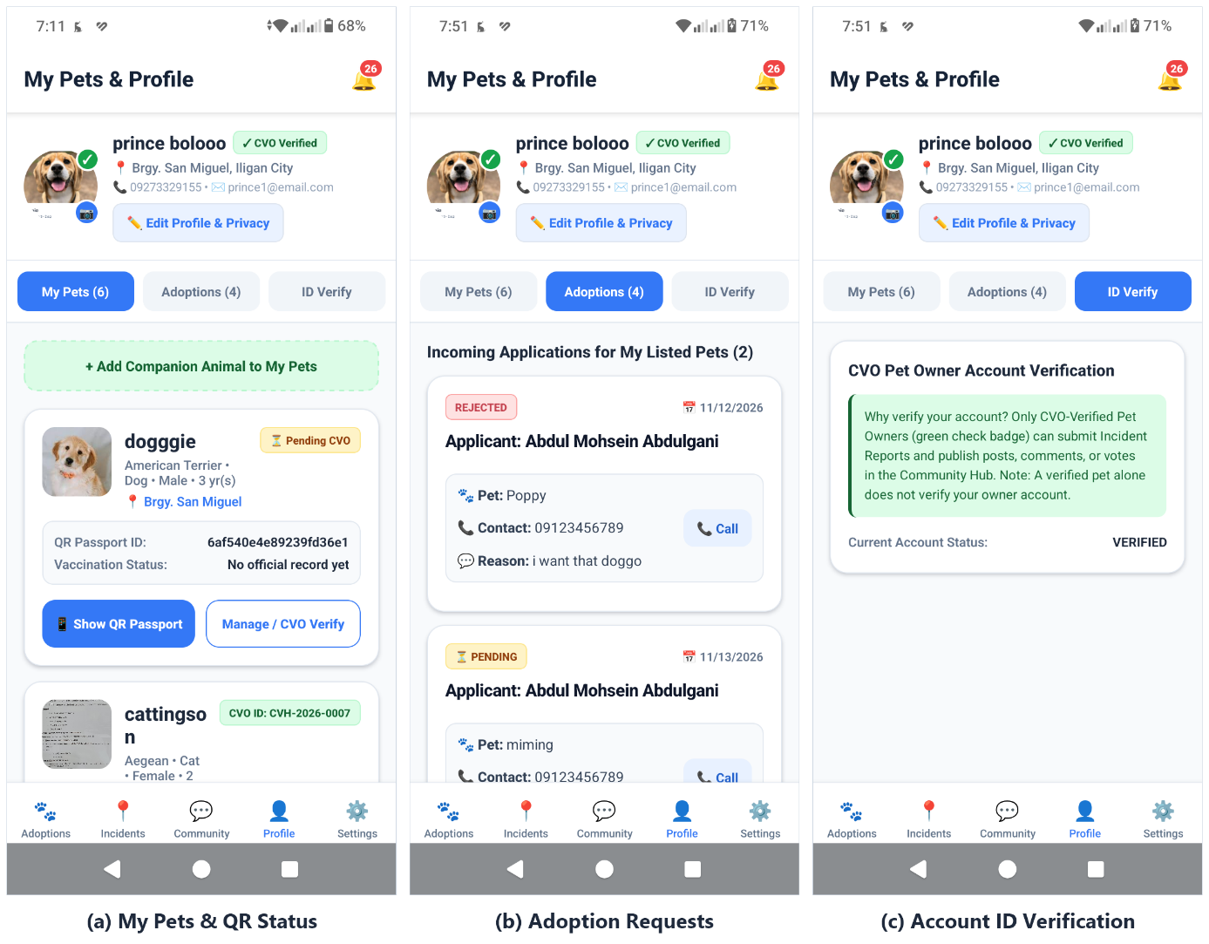
Figure 4.27 My Pets & Profile Screen (Mobile Application)
The My Pets & Profile Screen consolidates citizen account status, companion animal inventory, adoption request tracking, and government ID verification into three segmented tabs. Panel (a) presents the owner's avatar with quick camera upload controls, a CVO Verified badge, barangay address, contact summary, an Edit Profile & Privacy shortcut, and the My Pets list featuring a + Add Companion Animal to My Pets action alongside cards detailing pending or verified statuses, assigned CVO IDs (such as CVH-2026-0007), QR Passport IDs, vaccination status summaries, and Show QR Passport or Manage / CVO Verify buttons. Panel (b) illustrates the Adoptions tab displaying incoming applications for the user's listed pets with status tags, timestamps, applicant comments, and direct Call links, while Panel (c) displays the ID Verify tab explaining owner verification eligibility and confirming Verified account status.
Digital Pet Passport & QR Code Screen (Mobile Application)
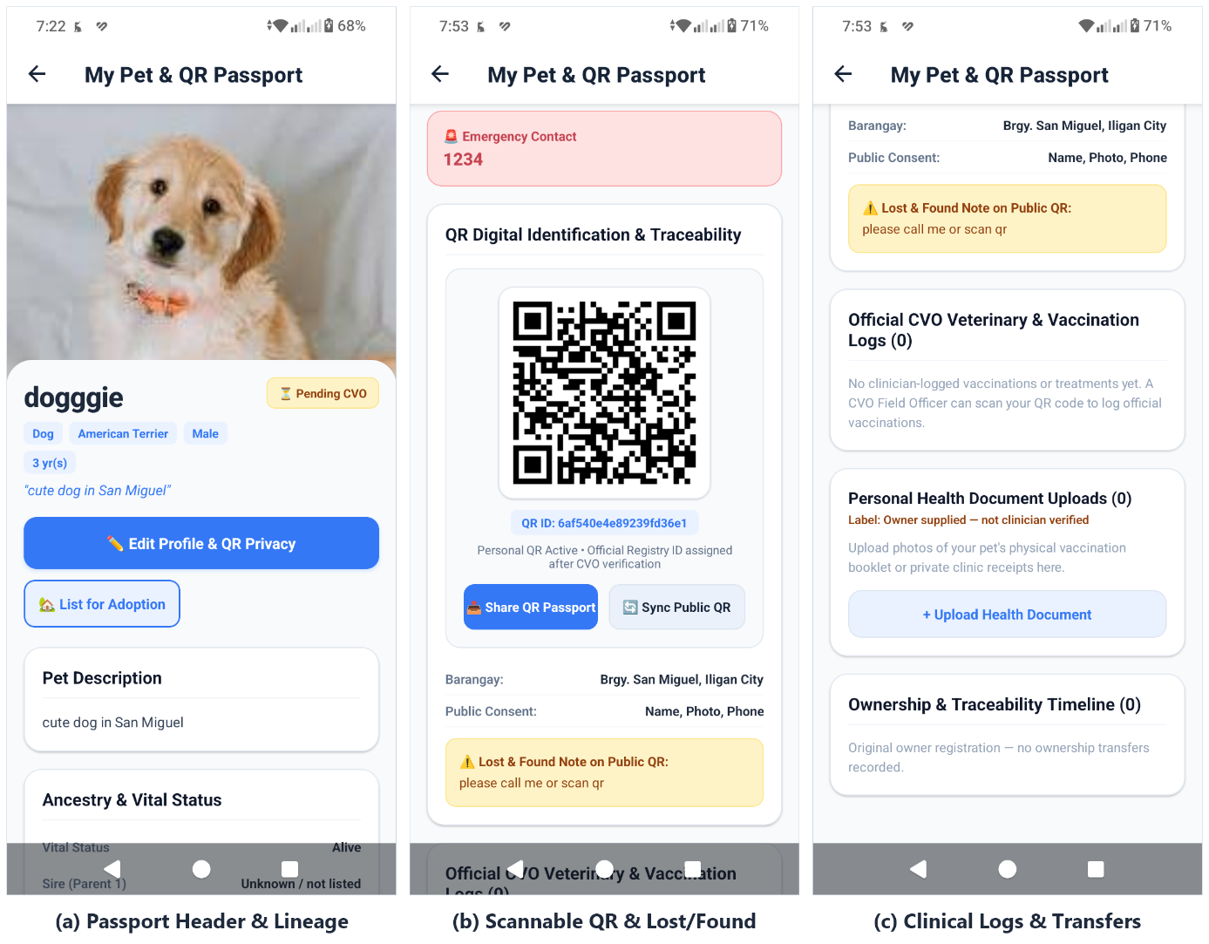
Figure 4.28 Digital Pet Passport & QR Code Screen (Mobile Application)
The Digital Pet Passport & QR Code Screen provides each companion animal with a scannable digital identification record, clinical logbook, and custody history supporting Chapter 1 Objective 2's smart traceability mechanism. Panel (a) shows the full-width pet header photograph, verification status badge (Pending CVO or CVO Verified), species, breed, sex, and age chips, full-width Edit Profile & QR Privacy and List for Adoption buttons, and Pet Description and Ancestry & Vital Status cards. Scrolling further, Panel (b) highlights the Emergency Contact banner, the scannable QR Digital Identification & Traceability module displaying the unique QR ID, Share QR Passport and Sync Public QR actions, barangay and public consent settings, and a Lost & Found Note callout. Panel (c) completes the passport view with the Official CVO Veterinary & Vaccination Logs section, Personal Health Document Uploads (explicitly labeled as owner-supplied), and the chronological Ownership & Traceability Timeline.
Settings & Push Notification Preferences Screen (Mobile Application)
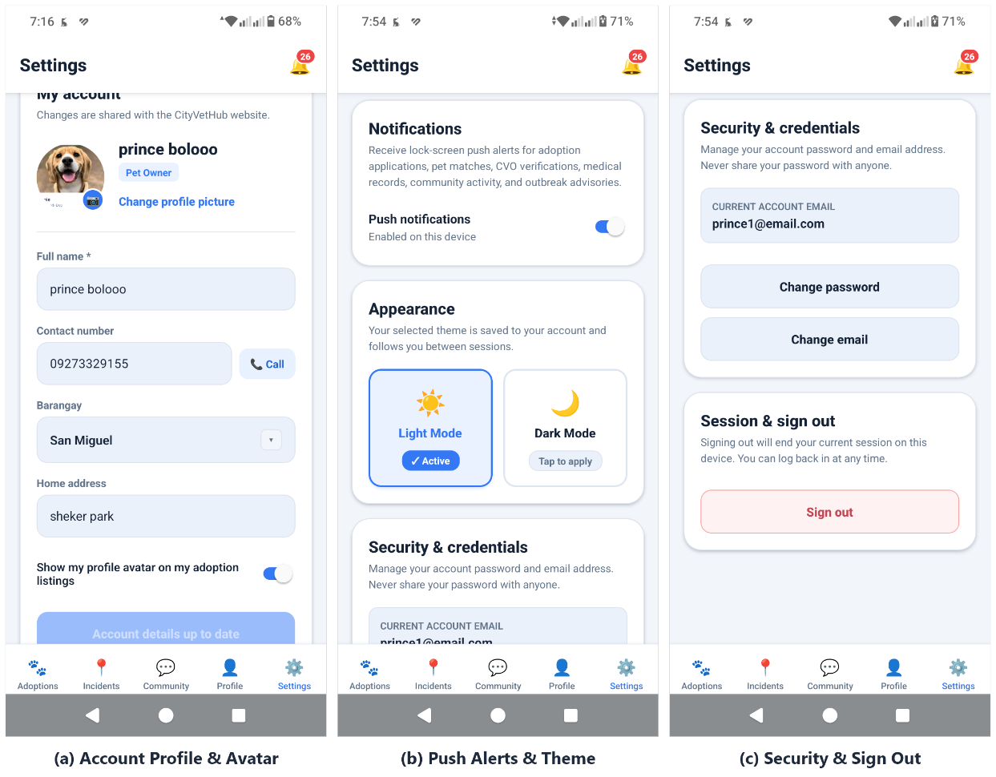
Figure 4.29 Settings & Push Notification Preferences Screen (Mobile Application)
The Settings & Push Notification Preferences Screen unifies profile editing, device alert controls, theme customization, and credential management across both Pet Owner and Field Officer accounts. Panel (a) presents the My account card synchronized with the CityVetHub web portal, showcasing the user's avatar upload controls, assigned role pill, editable full name, direct-dial contact number, searchable Iligan City barangay selector, home address, and an adoption-listing avatar sharing toggle. Panel (b) depicts the middle workspace featuring the device Push notifications toggle—covering adoption applications, pet matches, CVO verifications, medical records, community activity, and outbreak advisories—alongside interactive Light Mode and Dark Mode theme selection cards preserved between sessions. Panel (c) shows the bottom Security & credentials card displaying the active account email with Change password and Change email dialogs above the Session & sign out card.
Field Officer Interface (Mobile Application)
Field Pet Lookup, QR Scanner & Clinical Logging Screen (Mobile Application)
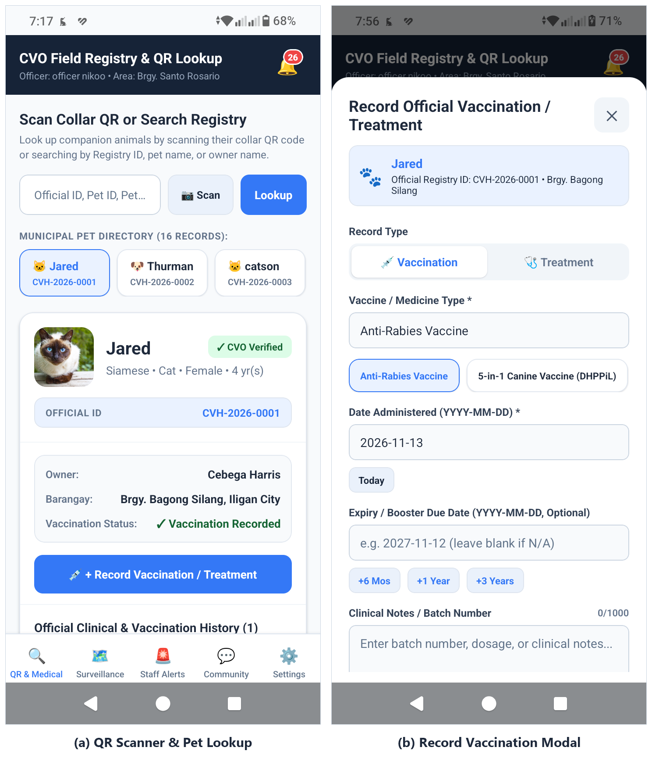
Figure 4.30 Field Pet Lookup, QR Scanner & Clinical Logging Screen (Mobile Application)
The Field Pet Lookup, QR Scanner & Clinical Logging Screen equips Field Officers with point-of-care animal identification and clinical recording inside the dedicated five-tab officer workspace (QR & Medical, Surveillance, Staff Alerts, Community, and Settings). Panel (a) shows the dark navy CVO Field Registry & QR Lookup header with officer attribution and assigned barangay, an input and camera Scan workflow paired with horizontal Municipal Pet Directory cards, and the selected pet's verified card displaying its CVO Verified badge, official CVH identifier (such as CVH-2026-0001), owner and barangay details, vaccination status, a + Record Vaccination / Treatment button, and the Official Clinical & Vaccination History log. Tapping the recording button opens the modal shown in Panel (b), allowing clinicians to toggle between Vaccination and Treatment records, select standard vaccine presets such as Anti-Rabies Vaccine or 5-in-1 Canine Vaccine (DHPPiL), autofill administration and booster expiry dates (+6 Mos, +1 Year, +3 Years), and enter batch numbers or clinical notes.
Field Incident Surveillance Map Screen (Mobile Application)
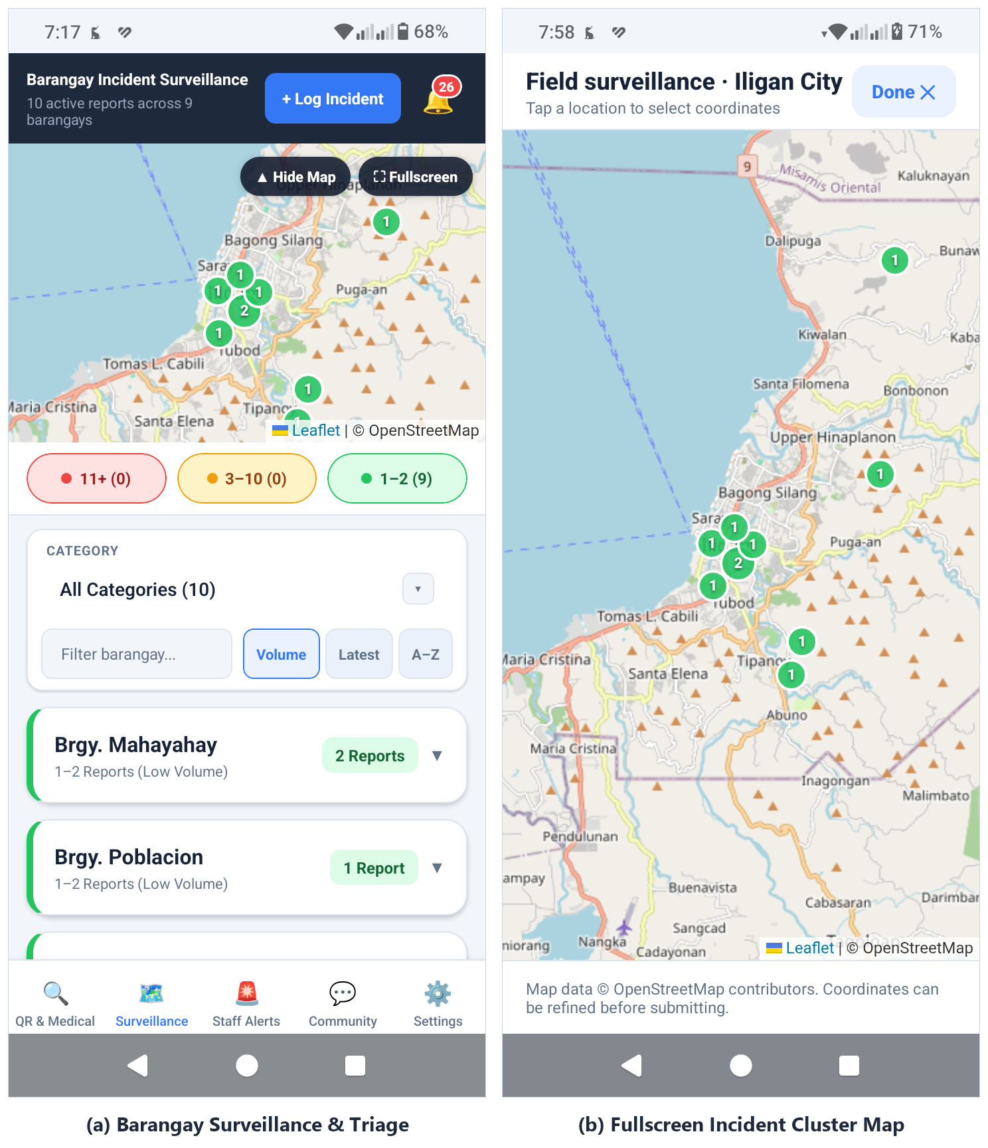
Figure 4.31 Field Incident Surveillance Map Screen (Mobile Application)
The Field Incident Surveillance Map Screen equips authorized Field Officers with spatially aggregated monitoring and triage of animal disease and stray reports across Iligan City barangays. Beneath the Barangay Incident Surveillance header reporting active case and barangay totals alongside a + Log Incident action, Panel (a) embeds an interactive Leaflet cluster map with Hide Map and Fullscreen controls, color-coded barangay volume legend pills distinguishing low (1–2 reports, green), moderate (3–10 reports, yellow), and high (11+ reports, red) caseload tiers, category and barangay search filters, Volume, Latest, and A-Z sort options, and expandable barangay cards for ocular dispatch. Expanding the map opens the Field surveillance view shown in Panel (b), presenting a full-screen Leaflet/OpenStreetMap canvas across Iligan City's barangays where clustered green markers indicate active report counts and staff can inspect or refine coordinates prior to logging field observations.
Outbreak Alerts & Ocular Queue Screen (Mobile Application)
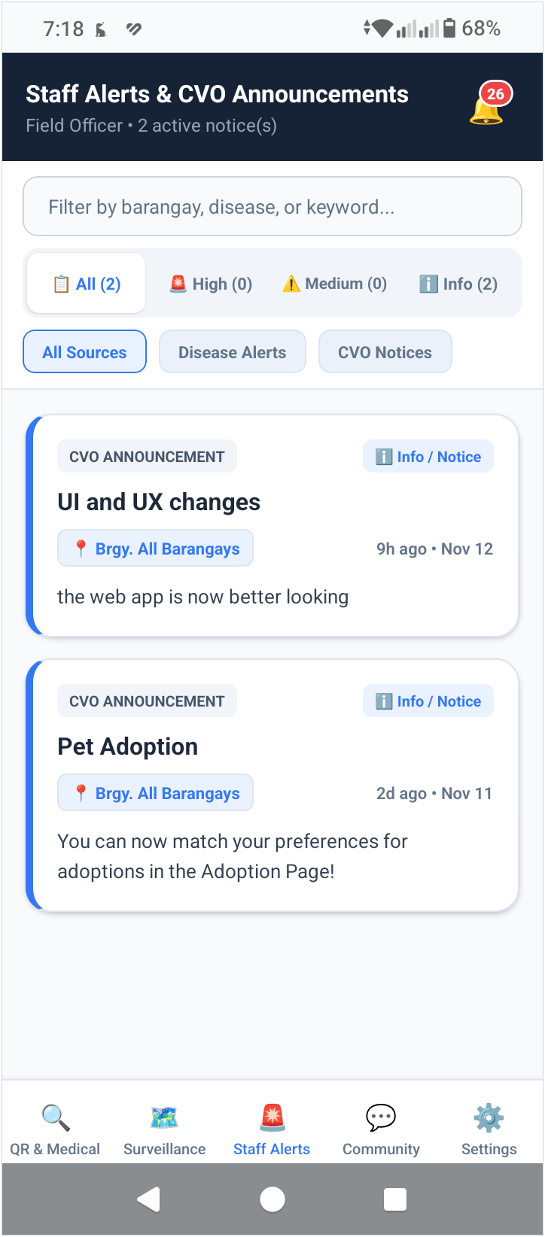
Figure 4.32 Outbreak Alerts & Ocular Queue Screen (Mobile Application)
The Outbreak Alerts & Ocular Queue Screen consolidates official City Veterinary Office disease alerts and administrative notices into a prioritized field briefing feed for veterinary personnel. Beneath the dark navy Staff Alerts & CVO Announcements header indicating Field Officer status and active notice counts, a keyword filter bar pairs with severity segmented tabs (All, High, Medium, and Info) and source filters distinguishing Disease Alerts from CVO Notices. Each notice card displays source and severity indicators (such as CVO ANNOUNCEMENT and Info / Notice), the broadcast title, targeted Iligan City barangay scope (for example, Brgy. All Barangays), relative and calendar publication timestamps, and full advisory messaging to coordinate timely field inspection and ocular response.
References

Krishna, B., Parvez, F. A., & Aparna, D. (2025). Animal (zoo) adoption system. International Journal of Information and Electronics Engineering, 15(4), 534-542. https://ijiee.org/index.php/ijiee/article/download/871/855/1737
Balinang, H., Tucjayao, N. J. D., Fernando, K. H. R., & Lagura, G. B. (2026). Exploring the conceptual dimensions of proposed e-government innovation in the Philippine local government unit. International Journal of Research and Innovation in Social Science (IJRISS). https://rsisinternational.org/journals/ijriss/view/exploring-the-conceptual-dimensions-of-proposed-e-government-innovation-in-the-philippine-local-government-unit
Implementing QR codes in academia to improve sample tracking, data accessibility, and traceability in multicampus interdisciplinary collaborations. (2023). PLOS One. https://pmc.ncbi.nlm.nih.gov/articles/PMC10079063/
Balinang, H., Tucjayao, N. J. D., Fernando, K. H. R., & Lagura, G. B. (2026). Exploring the conceptual dimensions of proposed e-government innovation in the Philippine local government unit. International Journal of Research and Innovation in Social Science, 10(2), 5036-5051. https://rsisinternational.org/journals/ijriss/view/exploring-the-conceptual-dimensions-of-proposed-e-government-innovation-in-the-philippine-local-government-unit
Hemavathy, K., & Varshini, B. (2024). Pet adoption portal [Mini project report, SNS College of Engineering]. Scribd. https://www.scribd.com/document/906599048/Mini-Project-He-Ma-Report
Alsuwailem, R., Almobarak, R., Aboali, R., Alrubaiea, S., & Aldossary, J. (2022). Leen: Web-based Platform for Pet Adoption. 2022 IEEE IAS Global Conference on Emerging Technologies (GlobConET), 775–780. https://doi.org/10.1109/globconet53749.2022.9872481
Blancaflor, E. B., Reyes, A. M., Romualdo, J. M. B., & Delos Santos, M. S. V. (2023). CareForPaws: A Mobile Application for Pet Adoption and Other Services with Location-based Technology Developed in React Native Framework. 2023 13th International Conference on Software Technology and Engineering (ICSTE), 31–36. https://doi.org/10.1109/icste61649.2023.00013
Bucao, W., Quinones, M. A. A., Abong, R. A., Penuela, C., & Sun, K. J. (2023). VETelgeuse: A Mobile and Web-Based Management System for Small and Medium-Scale Veterinary Clinics. Research Journal of Education, Science and Technology, 3. https://rjest.org/index.php/journal/article/view/55
Hofstra, G., Roelofs, J., Rutter, S. M., van Erp-van der Kooij, E., & de Vlieg, J. (2022). Mapping Welfare: Location Determining Techniques and Their Potential for Managing Cattle Welfare—A Review. Dairy, 3, 776–788. https://doi.org/10.3390/dairy3040053
Klune, J., Arhant, C., Windschnurer, I., Heizmann, V., & Schauberger, G. (2021). Tracking Devices for Pets: Health Risk Assessment for Exposure to Radiofrequency Electromagnetic Fields. Animals, 11, 2721. https://doi.org/10.3390/ani11092721
American Veterinary Medical Association. (n.d.). Canine parvovirus. American Veterinary Medical Association. https://www.avma.org/resources-tools/pet-owners/petcare/canine-parvovirus

Boyle, J. (2022). How to leverage Mapping APIs for real-time data visualization. Mapbox Developer Blog. https://www.mapbox.com/blog/real-time-data-visualization-apis

